
Security Level: | Confidential
Author: | Frode Nilsen
Last Edit Date: | 4 February, 2019
© 2018 Device Authority
This document contains proprietary and confidential information of Device Authority and shall not be reproduced or transferred to other documents, disclosed to others, or used for any purpose other than that for which it is furnished, without the prior written consent of Device Authority. It shall be returned to the respective Device Authority companies upon request.
The trademark and service marks of Device Authority, including the Device Authority mark and logo, are the exclusive property of Device Authority, and may not be used without permission. All other marks mentioned in this material are the property of their respective owners.

KeyScaler 6.3.1 Installation Single Tenant
Host OS: CentOS 7.5

Contents
1 Document Version Control 4
2 Assumptions and Open Issues 5
2.1 Assumptions 5
2.2 Open Issues 5
3 Introduction 6
3.1 Document Overview 6
3.2 Terms and Definitions 6
3.3 Related Documentation 6
4 KeyScaler Installation 7
4.1 Prerequisites 7
4.1.1 Software Bundle 7
4.1.2 Verify dfactor service is running 7
4.1.3 Hosts Entries 7
4.2 Installation Wizard 8
4.2.1 Welcome - Start the Wizard 8
4.2.2 Database Configuration 9
4.2.3 Apache Kafka Configuration 10
4.2.4 KMS Deployment 12
4.2.5 Message Queue Service Deployment 16
4.2.6 Memcached Configuration 18
4.2.7 Account Creation 18
4.2.8 System License 21
4.2.9 DAE Deployment 24
4.2.10 Message Queue Service Deployment 26
4.2.11 CP Deployment 27
4.2.12 Setup Complete 30
4.3 Helpful Information 37
4.4 Post-Installation Activities 38
4.4.1 Account Settings 38
4.4.2 Other Configuration Customization's 40
4.4.3 Master Account Setup 40
4.4.4 DAE And CP Configuration 40
4.5 Orientation to your KeyScaler System 41
4.5.1 Database 41
4.5.2 Linux User 42
4.5.3 Log files 42
4.5.4 Tomcat 42
4.5.5 Helpful Commands 42
4.6 Troubleshooting 44
4.6.1 Oh Snap! Maximum status check attempts exceeded 44
5 Service Access Controller Installation 44
5.1 Overview 44
5.2 On Standalone Server 45
5.2.1 Pre-requisites 45
5.2.2 Install Instructions 48
5.2.3 DNS Entry 52
5.2.4 Connectivity Tests 53
5.3 On Same Server 53
5.3.1 Install service-access-controller.war into Tomcat 54
5.3.2 Start the KeyScaler DFactor Service 54
6 End to End Sanity Test 55

Document Version Control
Version | Description | Date | Who | Comment
1.0 | Initial Document Creation | 20-Oct-18 | Frode Nilsen
Item 1 – Document Version Control

Assumptions and Open Issues

Assumptions
No | Description
1 | Software in this document has been tested on ThingWorx 8.2. It is assumed that the software will run on ThingWorx 8.3. Any issues to be listed in Item 3.
Item 2 - Assumptions

Open Issues
No | Description
Item 3 – Open Issues

Introduction

Document Overview

The Device Authority Setup Wizard is bundled in the custom Apache Tomcat distribution which was downloaded and installed in the DAE, KMS and CP Installation Prerequisites. This document assumes you have completed all the prerequisites outlined in the aforementioned document. During the Wizard, you will be deploying additional packages, creating public key files, uploading them to the Device Authority Customer Portal and downloading and deploying your custom-built software packages.

NOTE: Please use the instructions on the Wizard pages in combination with this document.

This document assumes that the reader has basic unix/linux knowledge.

Terms and Definitions
Term | Meaning
KMS | Key Management Store
DAE | Device Authority Engine
CP | Control Panel
DDKG | Dynamic Device Key Generator
Item 4

Related Documentation
Doc # | Document Name | Comment
 | DAKS-62-INST-KEYSCALER_PREREQUISITES | Complete pre-requisites before starting this document
 | DAKS-62-INST-KEYSCALER | This document
 | DAKS-62-INST-AGENT-MQTT_UBUNTU1604 | Installing and registering a device through the MQTT Device Agent
Item 5 – Related Documentation

KeyScaler Installation

Prerequisites

Software Bundle
You will need access to software that was bundled with the install scripts run in section 5.4.2 of [1]. This installation document assumes the path is /home/centos/installer/software, but your location may be different.

[root@test ~]# cd /home/centos/installer/software
[root@ software]# ls -l
total 76528
-rw-rw-r--. 1 501 501 28144676 Feb 10 01:05 cp.war
-rw-rw-r--. 1 501 501 10617082 Feb 10 01:05 kms.war
-rw-rw-r--. 1 501 501 39592965 Feb 10 01:05 service.war
[root@ software]#
Item 6 – installer software

Verify dfactor service is running
Check to see that the dfactor service is running:
[root@test ~]# service dfactor status
DeviceAuthority D-Factor (pid 16535) is running...
Item 7

Hosts Entries
The following host names will be used by KeyScaler throughout installation. Resolve these by adding entries to /etc/hosts on the server on which KeyScaler is being installed.

[root@ip-172-31-47-94 cert]# vi /etc/hosts
127.0.0.1 localhost localhost.localdomain localhost4 localhost4.localdomain4
::1 localhost localhost.localdomain localhost6 localhost6.localdomain6

127.0.0.1 kms.ksaws.com
127.0.0.1 kafka.ksaws.com
127.0.0.1 dae.ksaws.com
127.0.0.1 queue.ksaws.com
127.0.0.1 cp.ksaws.com
127.0.0.1 sac.ksaws.com
Item 8 – KeyScaler Server – This domain name ksaws matches the one set when creating the wildcard certificate in the pre-requisite document. Please update this to match your own domain name.

Installation Wizard

Welcome - Start the Wizard
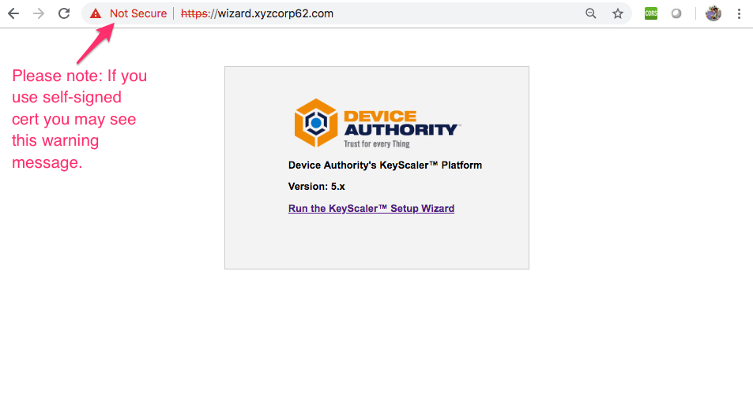
Item 9

Start the Wizard by using a browser window to navigate to e.g. https://wizard.ksaws.com (replacing organization as appropriate). The Device Authority Setup Wizard is intended to be used in a start-to-finish manner and does not allow you to repeat steps. You may however, exit the Wizard at any time.

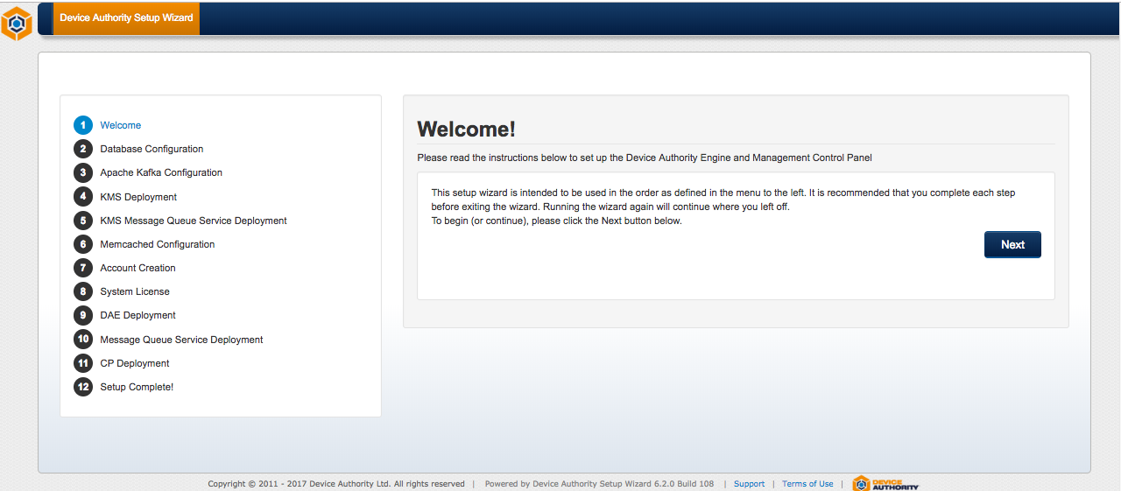
Item 10 – KeyScaler Installation Wizard

Database Configuration
Please note: only one of the following subsections should be completed, depending on your database configuration.

Default MySQL Database
The database details used when creating your database during the installation of MySQL are provided for you.

- The database host name must the same as used when granting table permissions in the database configuration step. This was set to "localhost" by the install script.
- The database port number is set to the default of 3306 which is recommended.
- The default Database Name is dfactordb
- The default database username is dfactor_user. Change this value if you modified the password during the installation prerequisites.

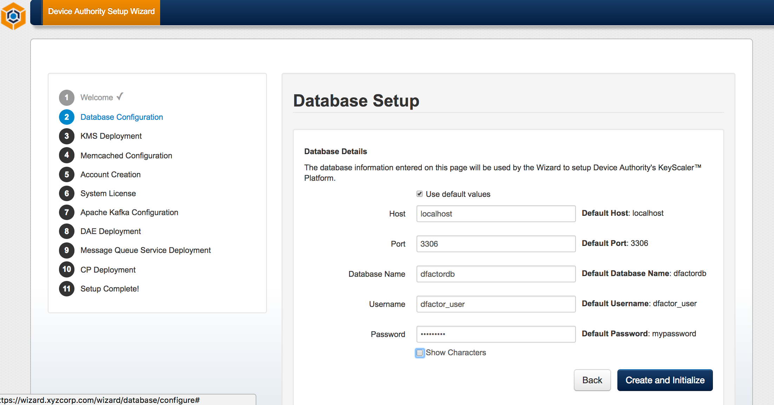
Item 11 - KeyScaler Installation Wizard

Azure MySQL Database
If you are installing KeyScaler with an Azure Managed MySQL database, below provides an example configuration and what needs to be entered into the Wizard page.

Host: keyscaler-mysql.mysql.database.azure.com
Port: 3306
Database Name: dfactordb
Username: fnilsen@keyscaler-mysql
Password: yourpassword

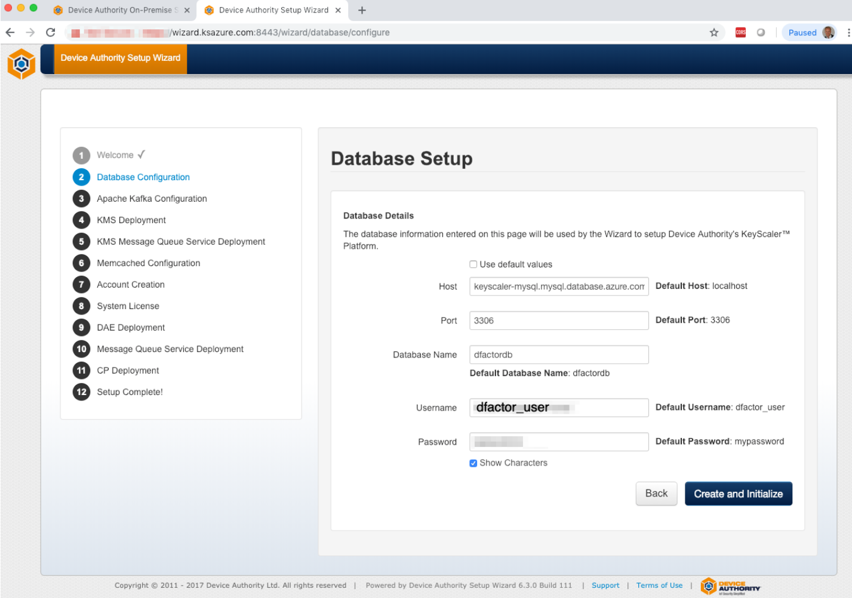
Item 12

Apache Kafka Configuration

Update server.properties
[root@ config]# vi /opt/kafka_2.11-1.0.0/config/server.properties
Item 13
Update the following line listeners=PLAINTEXT://kafka.ksaws.com:9092 to match your domain.

# The address the socket server listens on. It will get the value returned from
# java.net.InetAddress.getCanonicalHostName() if not configured.
# FORMAT:
# listeners=listener_name://host_name:port
# EXAMPLE:
# listeners=PLAINTEXT://your.host.name:9092
listeners=PLAINTEXT://kafka.ksaws.com:9092
Item 14 – Update Kafka server.properties

Start Zookeeper as daemon
[root@host ~] /opt/kafka_2.11-1.0.0/bin/zookeeper-server-start.sh -daemon /opt/kafka_2.11-1.0.0/config/zookeeper.properties
Item 15 – Start Sookeeper as a daemon

Start Apache Kafka as daemon
[root@host ~]# /opt/kafka_2.11-1.0.0/bin/kafka-server-start.sh -daemon /opt/kafka_2.11-1.0.0/config/server.properties
Item 16 – Start Apache Kafka as daemon

Verify that Kafka is running indicated by output shown in Item 17. If there is no output, please ensure that you have correct entry in hosts file (Item 8)
[root@host ~]# ps ax | grep -i 'kafka\.Kafka'
Item 17 – Check if Kafka is running. If there is no output, it is not running. If there is output (Item 17), kafka is running.
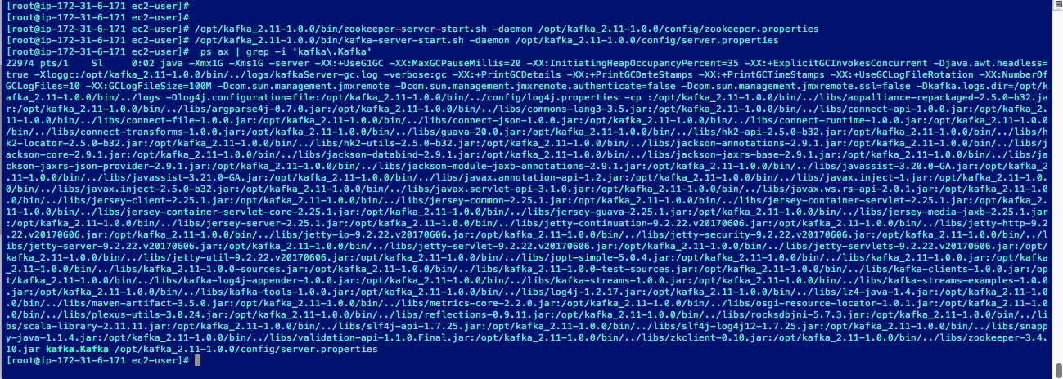
Item 18
Enter kafka.ksaws.com:9092 and click Next

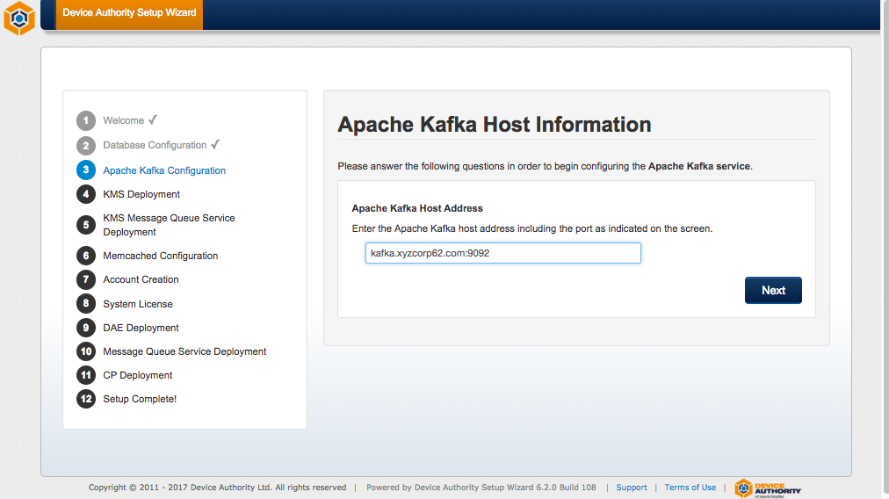
Item 19 - KeyScaler Installation Wizard

Click on the Check Status button.
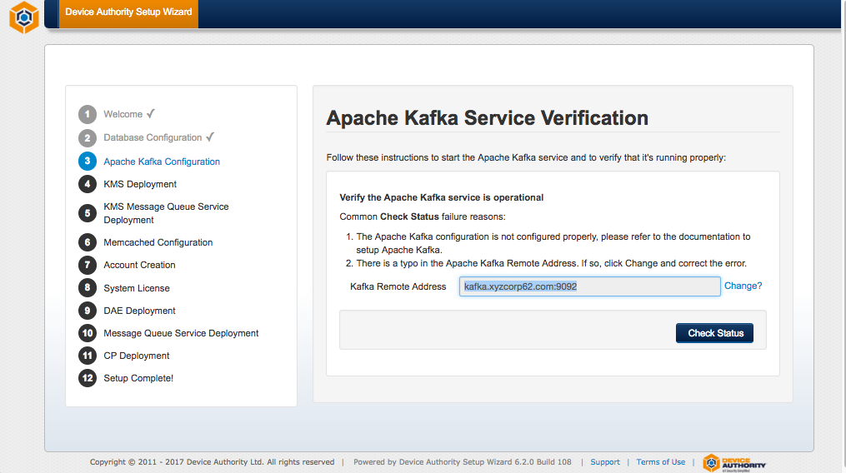
Item 20- KeyScaler Installation Wizard

 | If you encounter the error “Oh Snap! Ajax query failed for health check request” please check your /etc/hosts file that you have the correct entry and ensure that Kafka is running: ps ax | grep -i 'kafka\.Kafka'. If Kafka is not running, start it as shown above.

Once the wizard page shows a success message, Click Next as shown below:
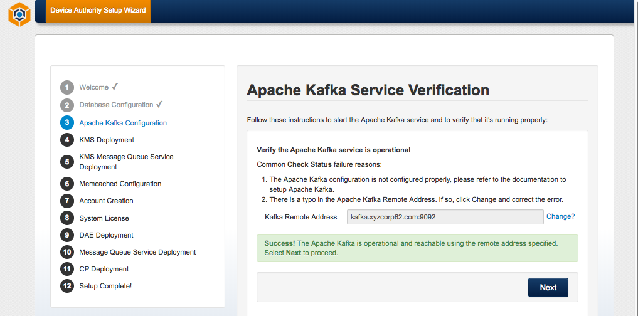
Item 21- KeyScaler Installation Wizard

KMS Deployment
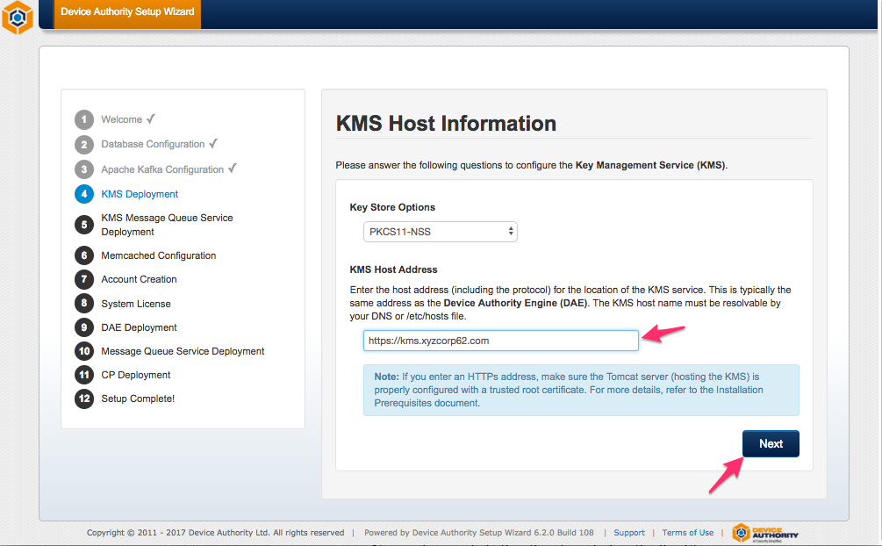
Item 22 - KeyScaler Installation Wizard

KeyStore Initialization
No input is needed other than to initialize the KeyStore.
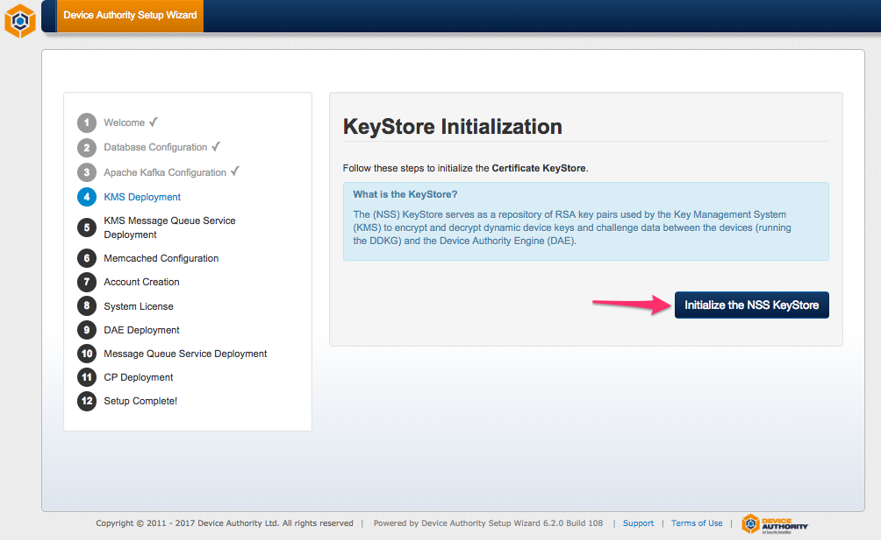
Item 23 - KeyScaler Installation Wizard

KMS Configuration
Values entered elsewhere are displayed for your confirmation. If these are correct, click Next.
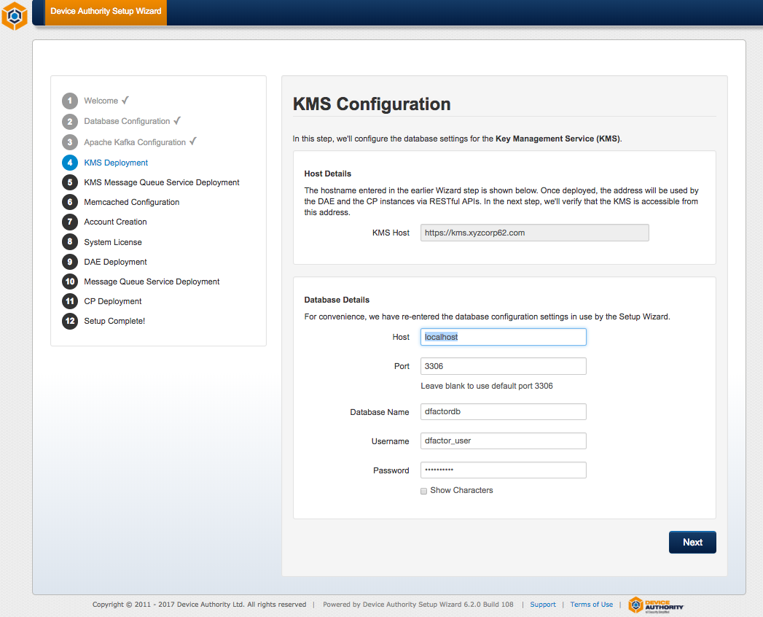
Item 24 - KeyScaler Installation Wizard

KMS Deployment
The KMS war file will be deployed in this step and assumes that all the required IP rules have been properly configured as performed by the installer script in the DAE, KMS and CP Installation Prerequisites. Follow the instructions in the Wizard to copy (deploy) the KMS war file to the tomcat webapps directory. Once deployed, click the Check Status button to verify the KMS has deployed successfully.

[root@ip-172-31-42-166 software]# cd /home/centos/installer/software
[root@ip-172-31-42-166 software]# cp kms.war /var/www/tomcat/webapps
Item 25

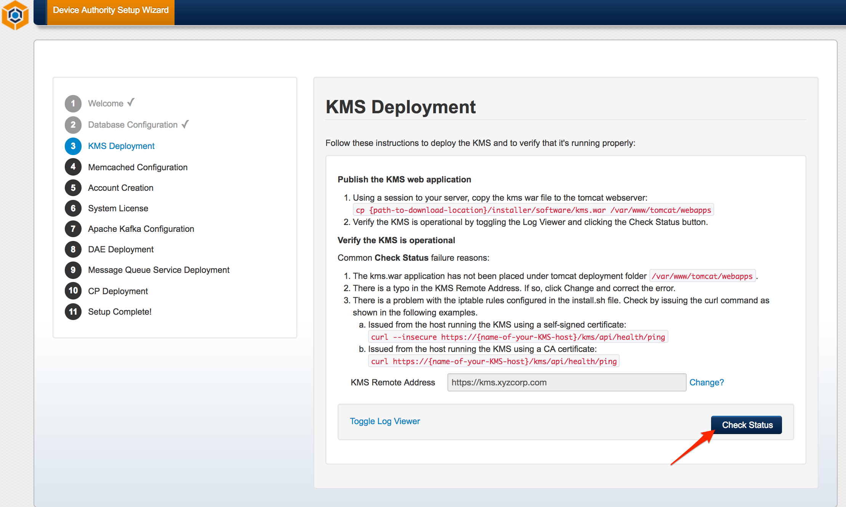
Item 26- KeyScaler Installation Wizard

The following message indicates success
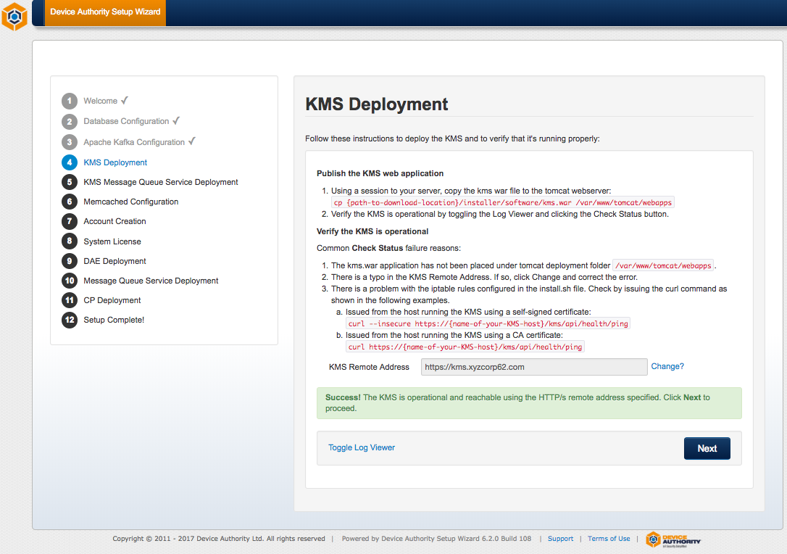
Item 27- KeyScaler Installation Wizard

Message Queue Service Deployment

KMS Message Queue Host Information

Please enter the following Message Queue host address, e.g. https://queue.ksaws.com, as shown below and click Next.

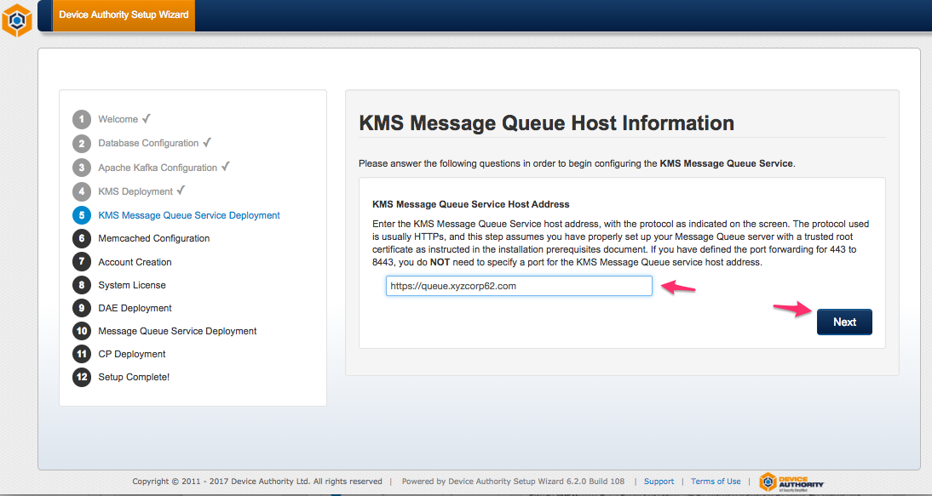
Item 28 - KeyScaler Installation Wizard

Message Queue Deployment
Deploy the following war file.

[root@ip-172-31-42-166 software]# cd /home/centos/installer/software
[root@ip-172-31-42-166 software]# cp kms-uservice.war /var/www/tomcat/webapps
Item 29 – KeyScaler Server

Click the Check Status button and you should see a green success message after a couple of seconds.

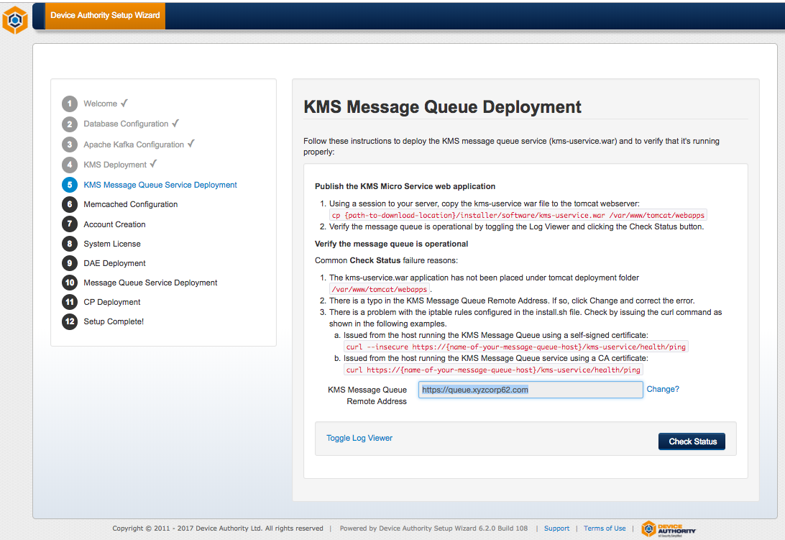
Item 30 - KeyScaler Installation Wizard

Click Next to proceed.
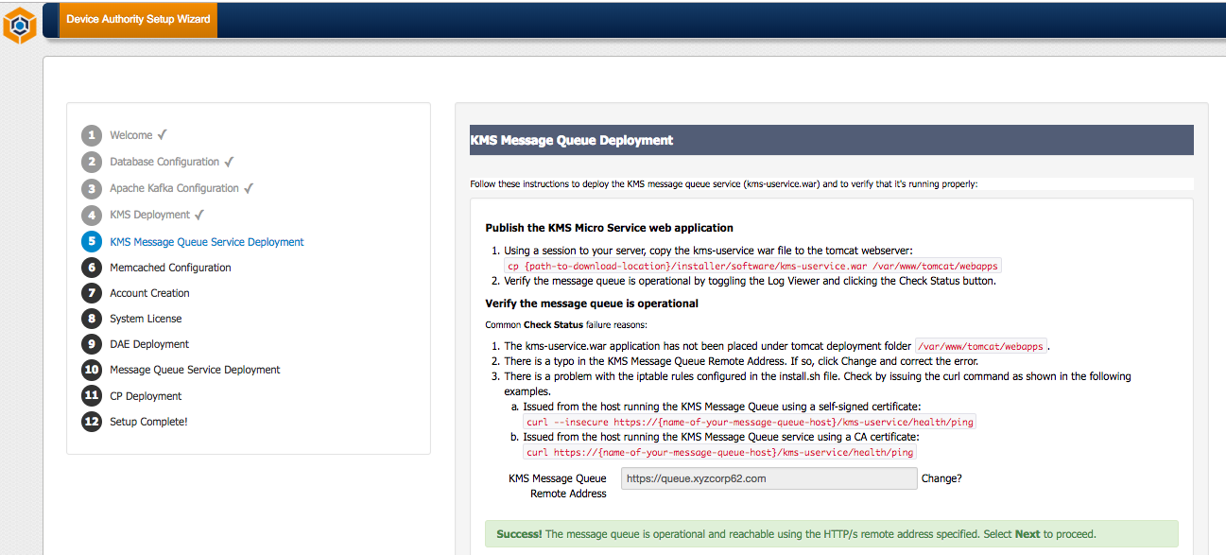
Item 31 - KeyScaler Installation Wizard

Memcached Configuration
The Memcached server address is localhost:11211

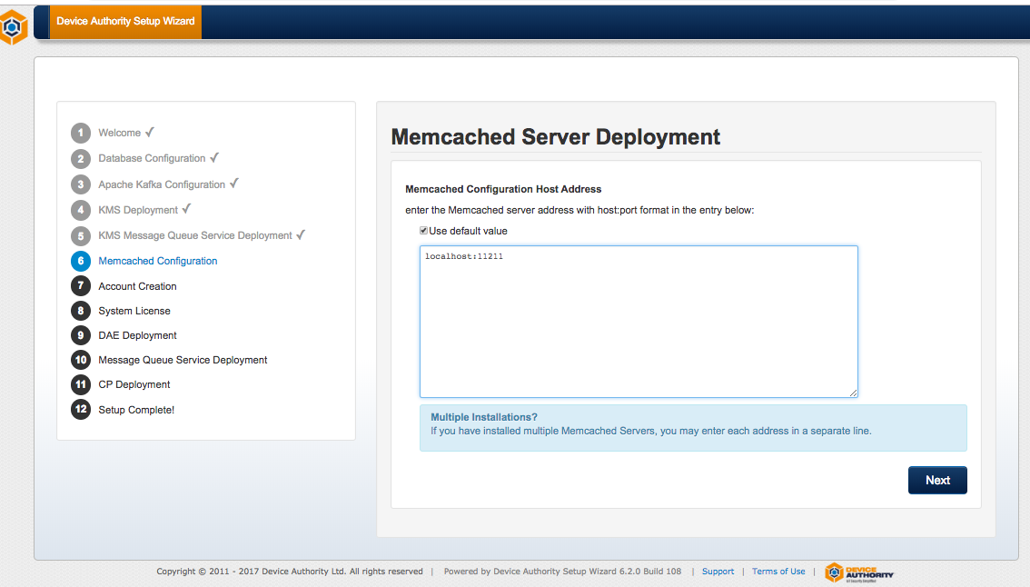
Item 32 - KeyScaler Installation Wizard

Account Creation
The Device Authority IoT Security Platform is a multi-tenant application. You will be creating a Master account and one Tenant account.

Master Account Creation
In the Master Account Creation step, you will be defining details about the Master Account. The Master Account allows you to configure and manage system-wide settings and tenant accounts. Make note of the account information used as you'll need it to access the Management Control Panel and register your device.

The Master Tenant Sub-Domain Name will be used as the sub-domain when accessing the Management Control Panel, so choose something simple and easy to type. Common sub-domain names for the Master Account are master, or cp.
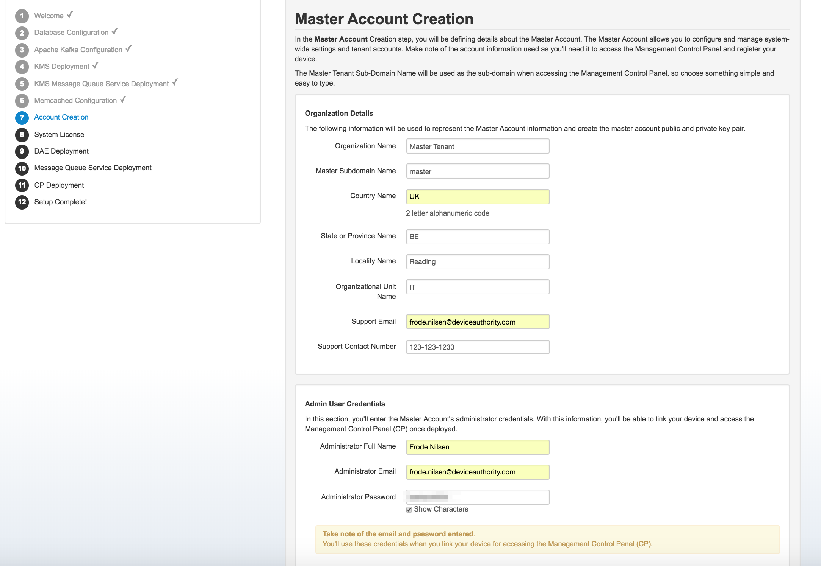
Item 33 - KeyScaler Installation Wizard

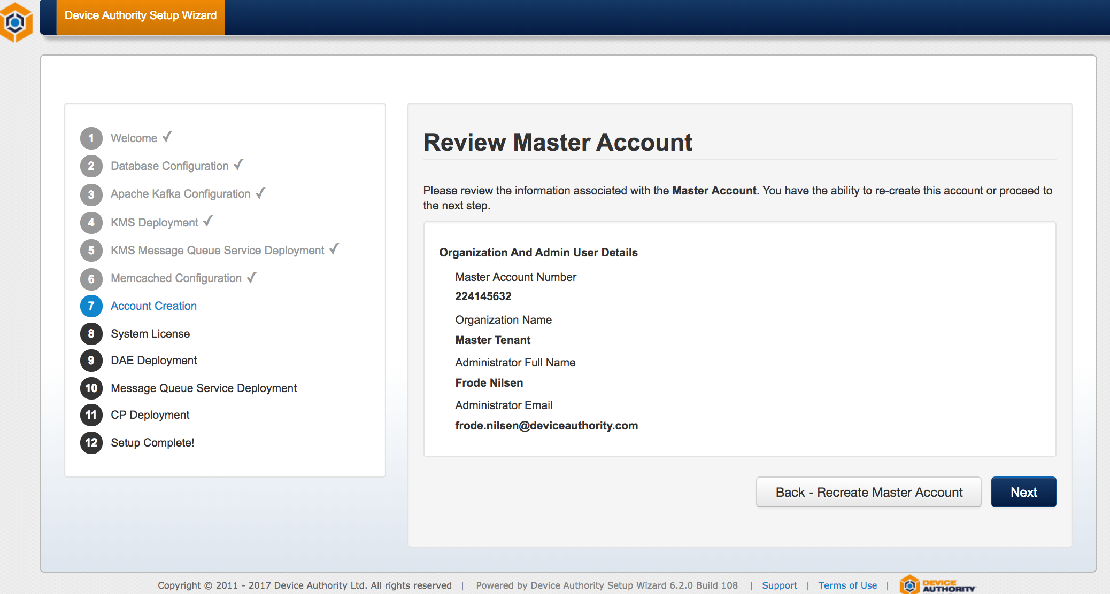
Item 34 - KeyScaler Installation Wizard

Tenant Account Creation
The Tenant Account is tied to the application(s) and/or service(s) you are protecting. Make note of the account information used here as well. The Tenant Sub-Domain Name will be used as the sub-domain when accessing the Management Control Panel, so choose something simple and easy to type. For example, you could use devtenant for the Tenant Account sub-domain name.

Note: The Master and Tenant email address used for administrator access can be the same.

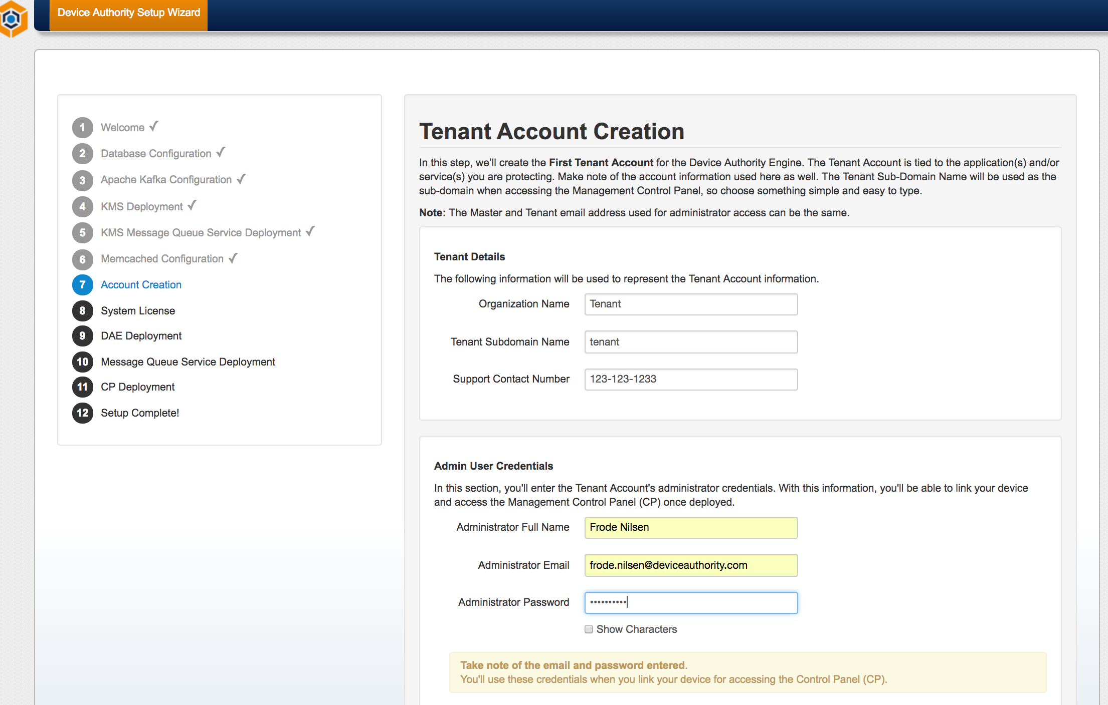
Item 35 - KeyScaler Installation Wizard

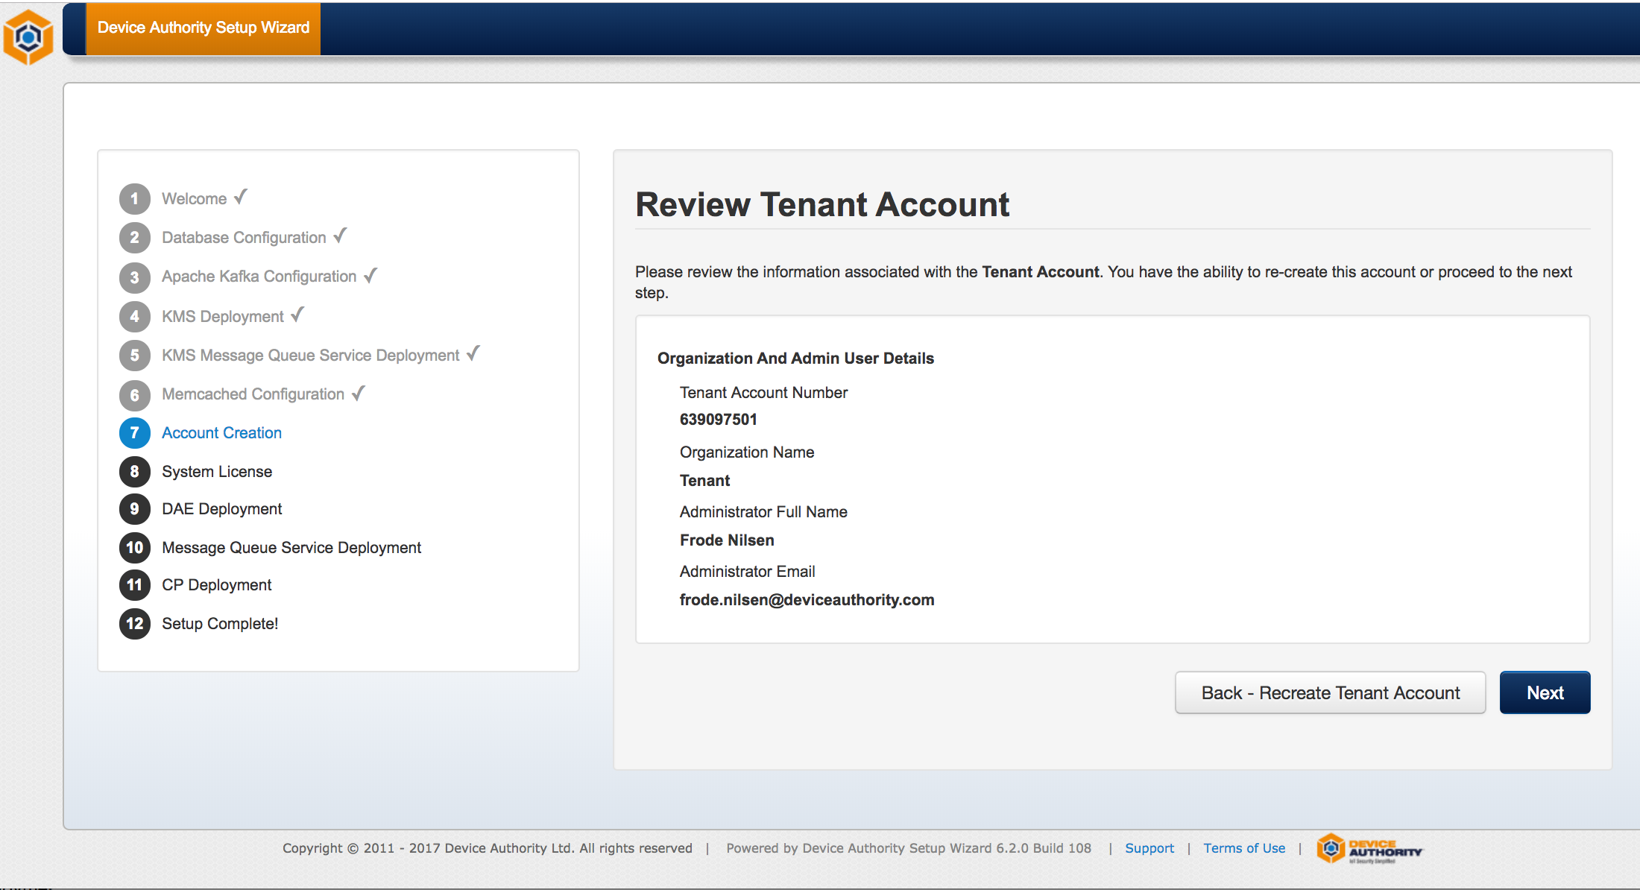
Item 36 - KeyScaler Installation Wizard

Download DAE Account Public Keys
In this step, you download your master and tenant public keys. These files (or ones created again in the future) will be used to build your custom DDKG generator packages. Click on the buttons to download the Public Key files. These xml files are not needed at this time. Then click Next to continue.
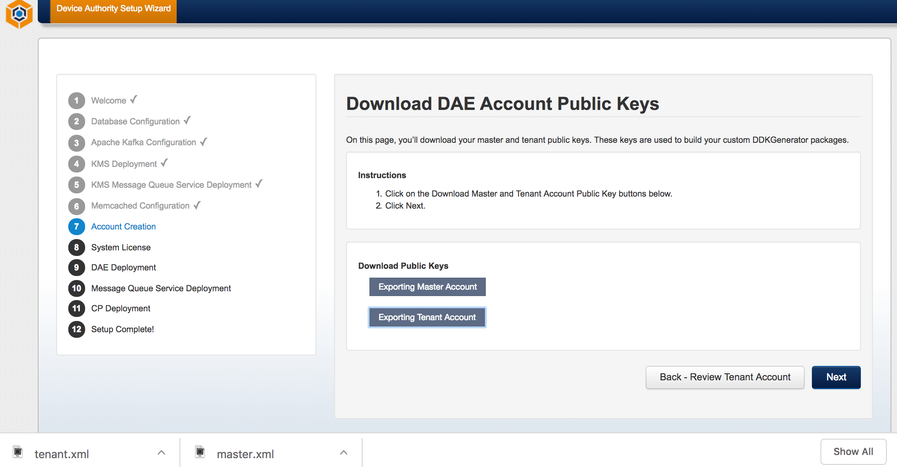
Item 37 - KeyScaler Installation Wizard

System License

Import System License
If you haven't already downloaded your system license, go to the Device Authority Customer Portal, Product License page and click the Download License button. Transfer the license file to your server.

- Locate and open the license file using an editor. Copy the contents of the file.
- Navigate back to the Wizard and paste it into the window provided. Then click Import System License.
If the import is successful, you will automatically proceed to the next step. If the import is unsuccessful, retry the copy/paste and make sure there are no missing nor extra characters copied.

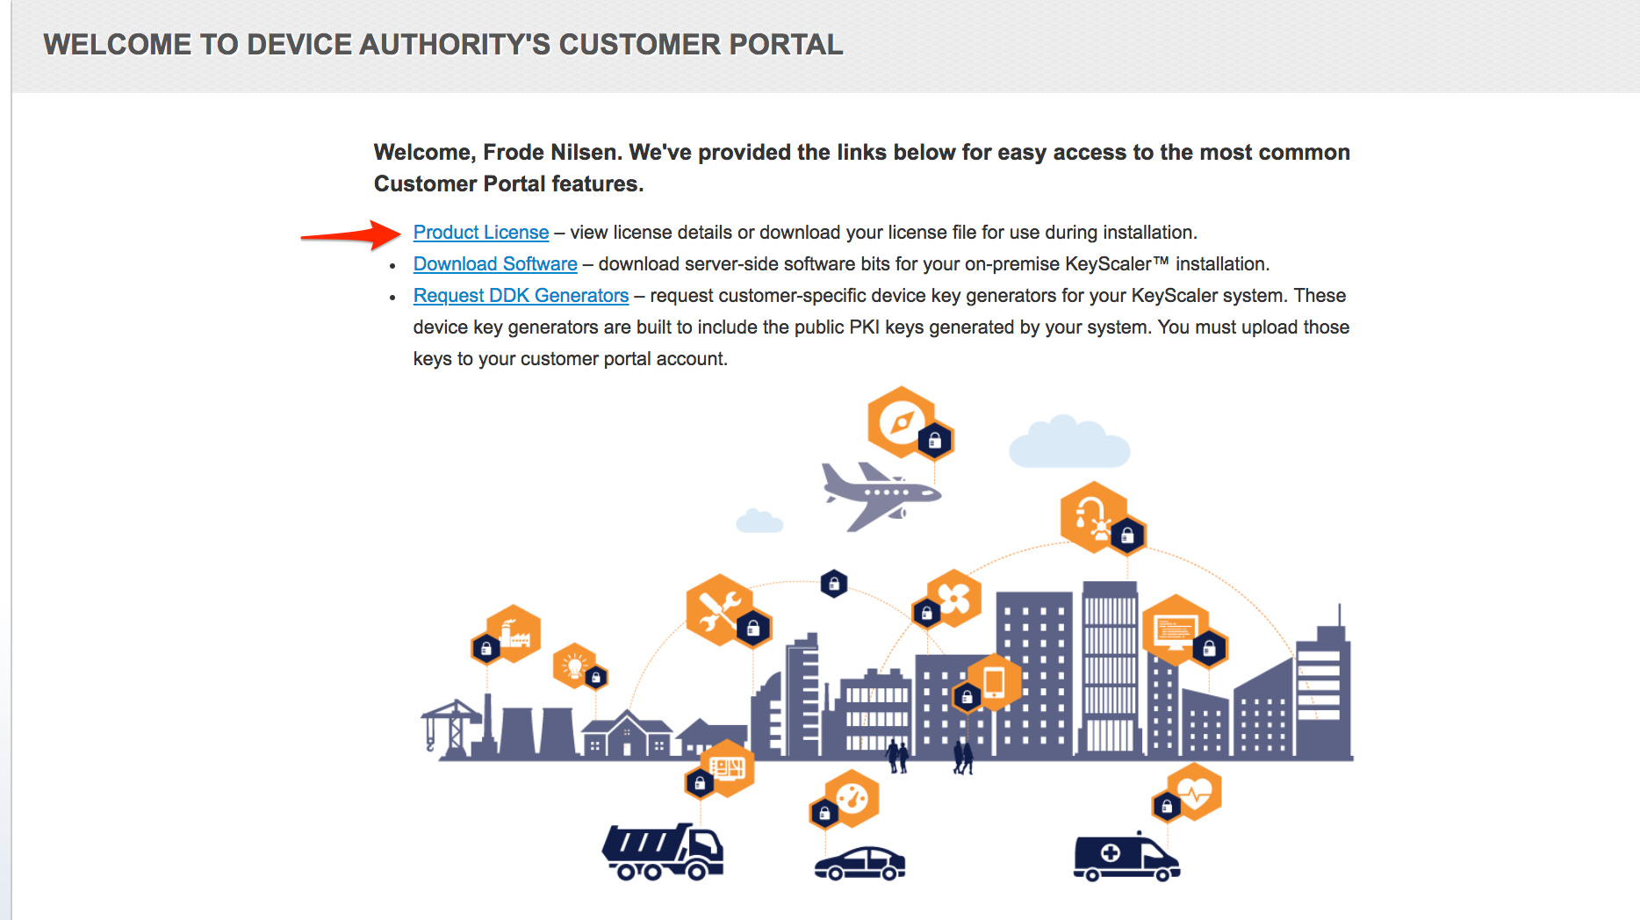
Item 38 - KeyScaler Customer Portal

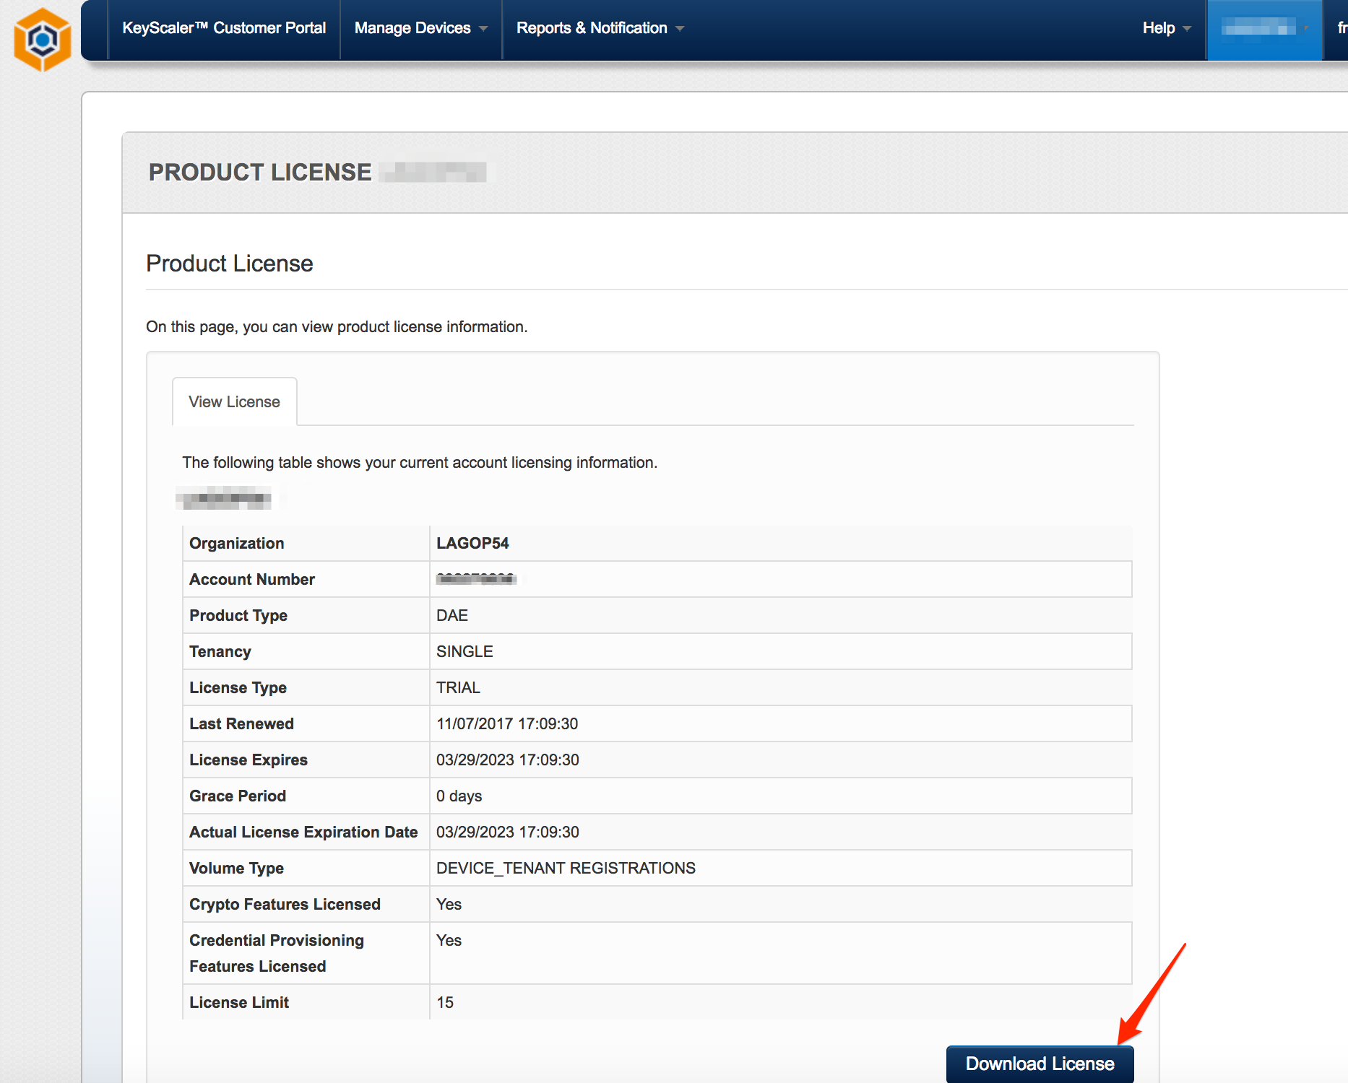
Item 39 - KeyScaler Installation Wizard

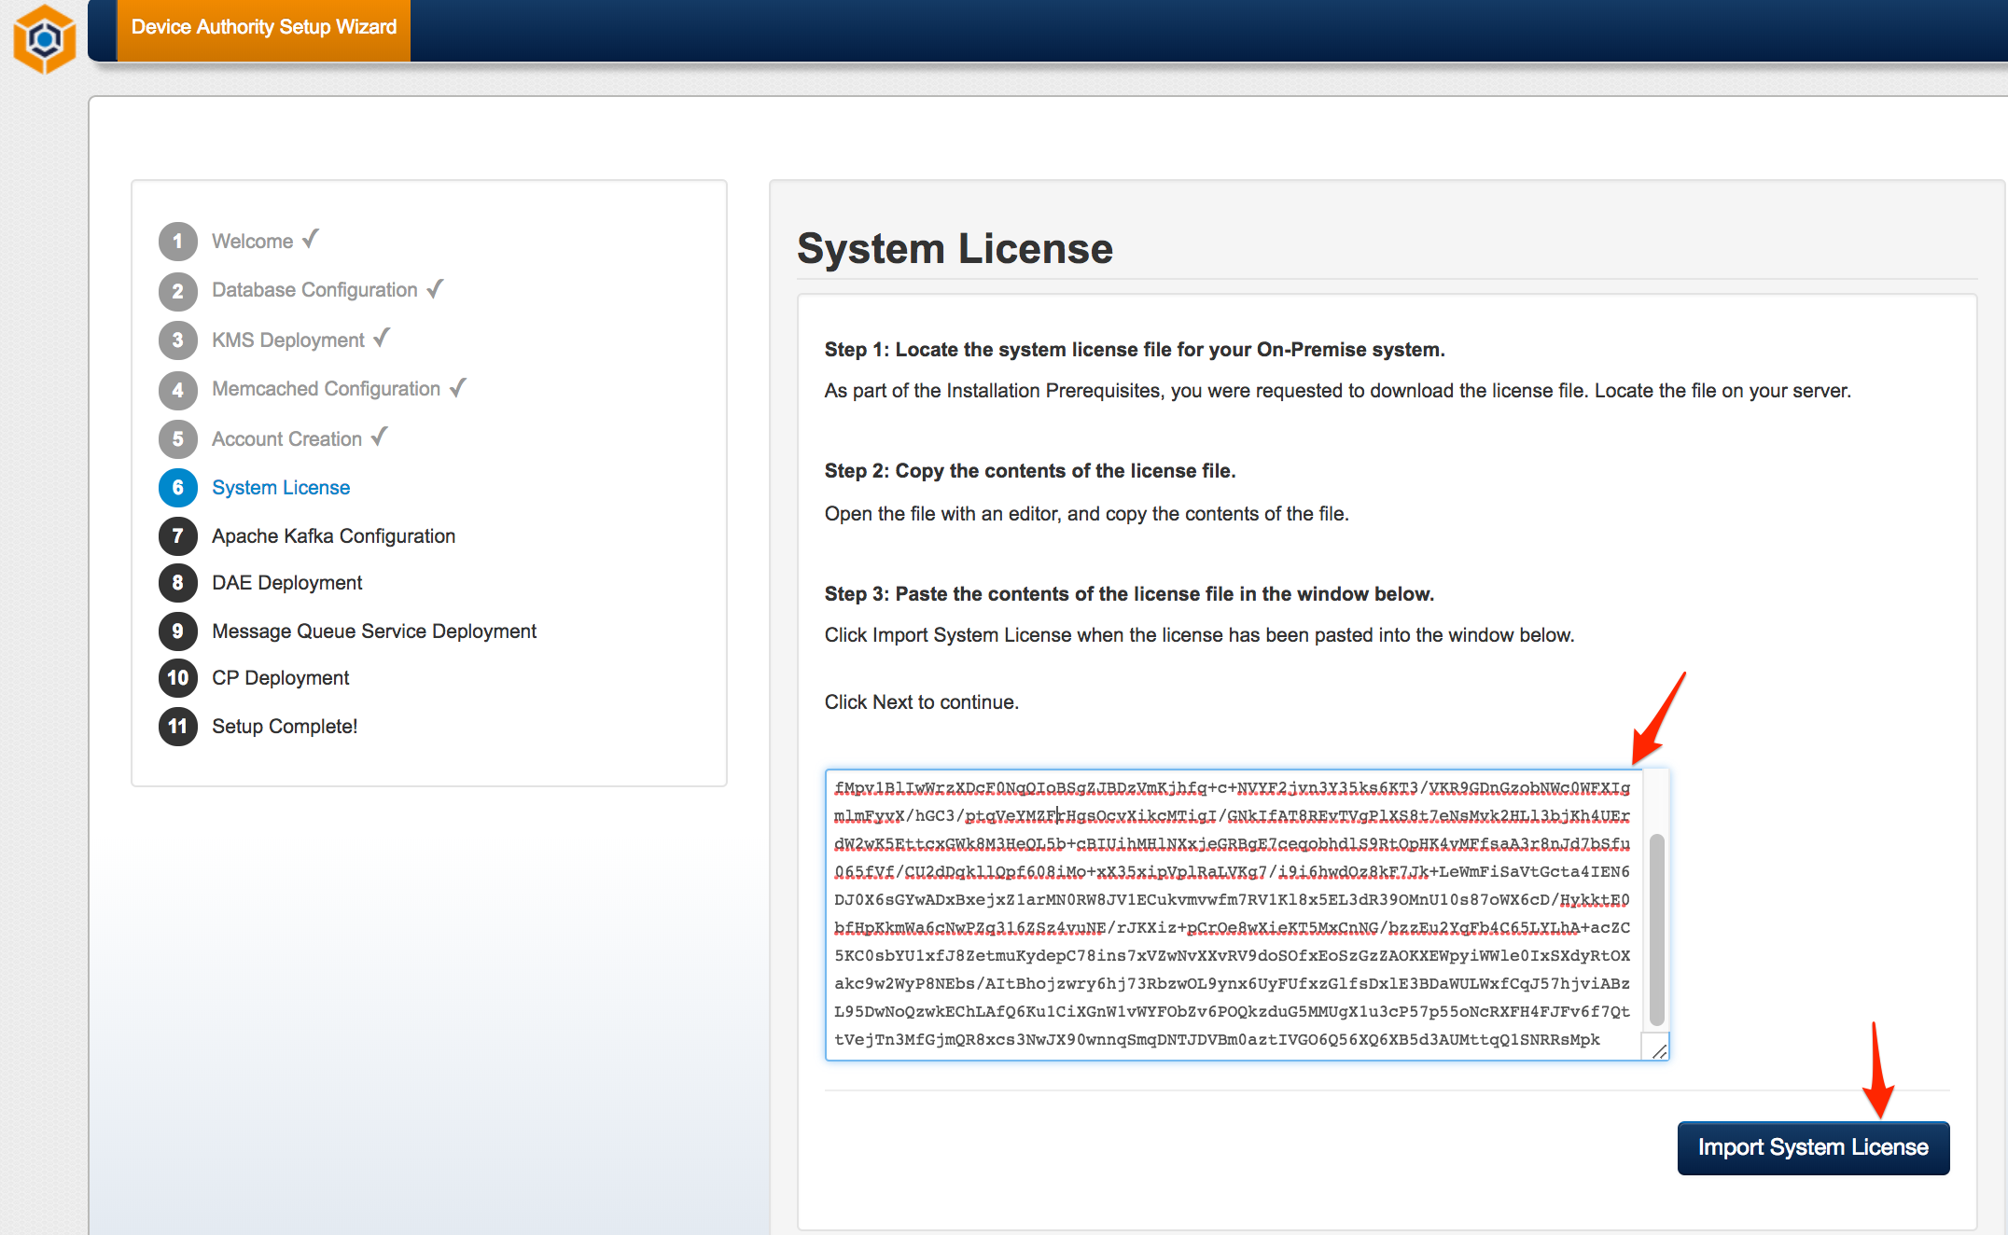
Item 40 - KeyScaler Installation Wizard

DAE Deployment

DAE Host Information
Enter the DAE host address, as shown below.

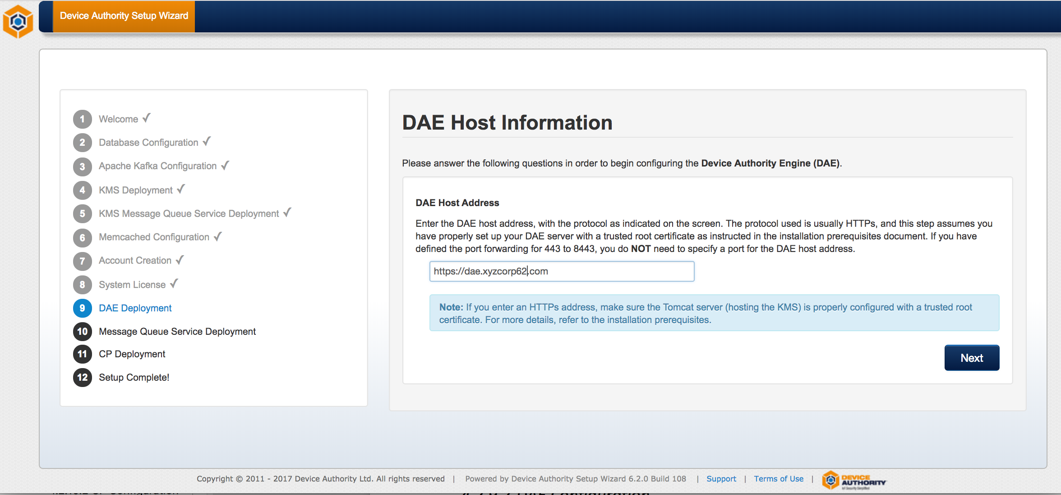
Item 41 - KeyScaler Installation Wizard

DAE Configuration

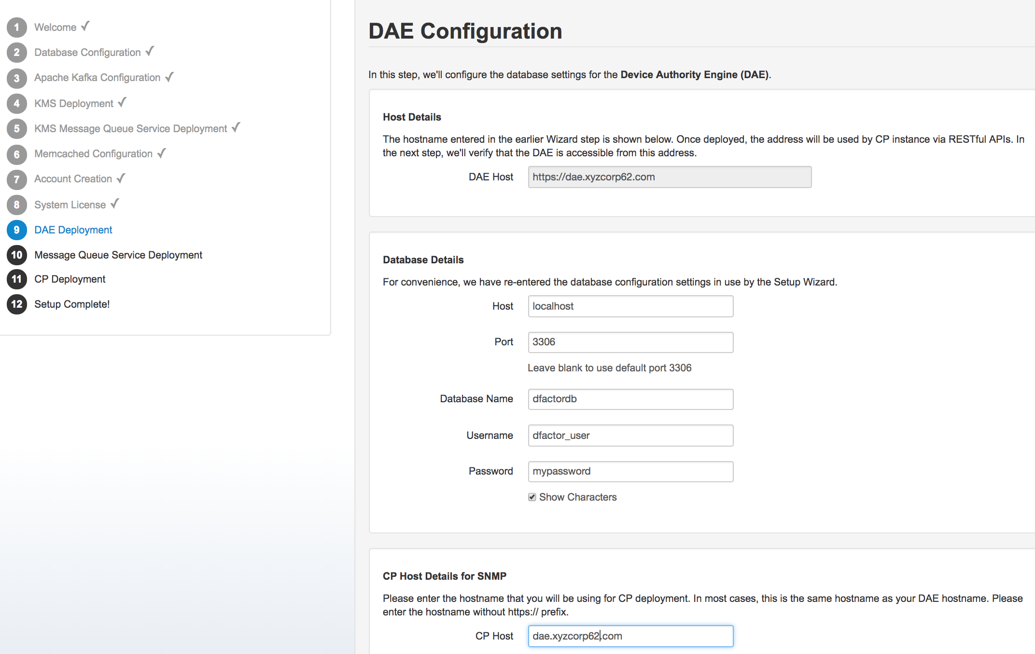
Item 42 - KeyScaler Installation Wizard

DAE Deployment
Copy the DAE (service.war file) to the tomcat webapps directory. Once deployed, click the Check Status button to verify the DAE has deployed successfully, and toggling the log viewer.

[root@ip-172-31-42-166 software]# cd /home/centos/installer/software
[root@ip-172-31-42-166 software]# cp service.war /var/www/tomcat/webapps
Item 43

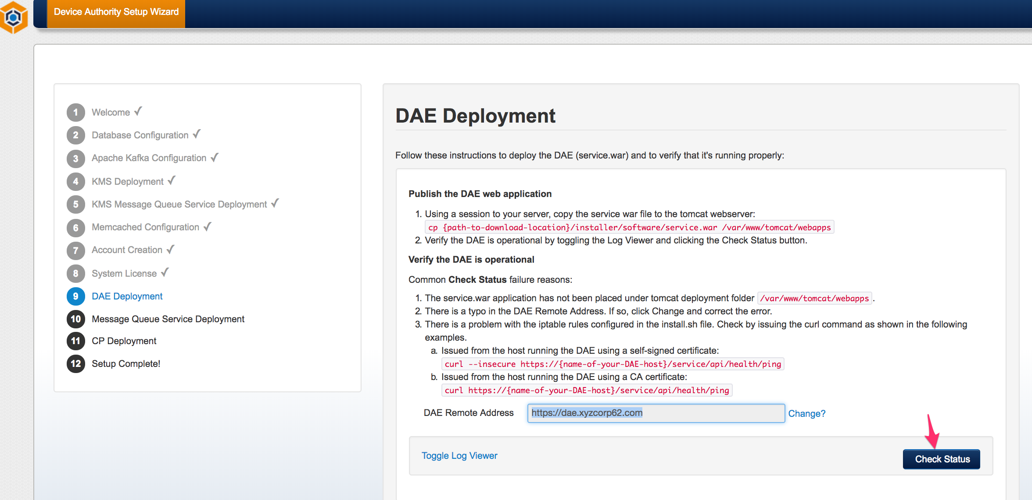

Item 44 – KeyScaler Installation Wizard
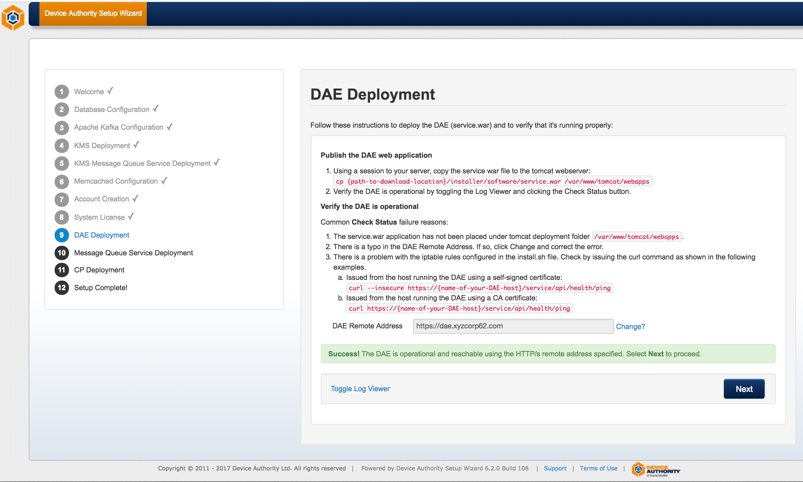
Item 45 - KeyScaler Installation Wizard

Message Queue Service Deployment
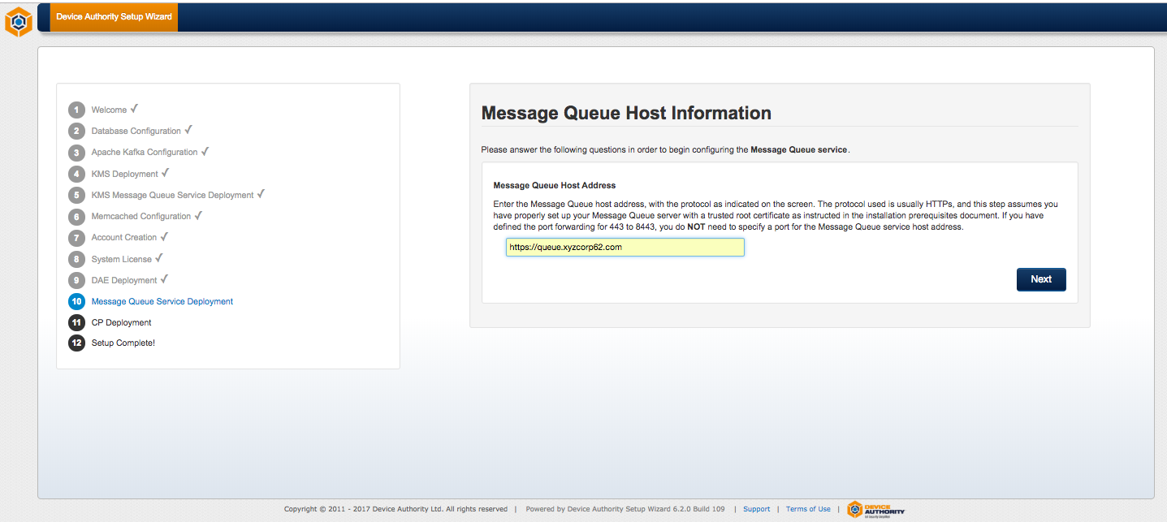
Item 46 - KeyScaler Installation Wizard
[root@ip-172-31-42-166 software]# cd /home/centos/installer/software
[root@ip-172-31-42-166 software]# cp keyscaler-services.war /var/www/tomcat/webapps
Item 47 – KeyScaler Server

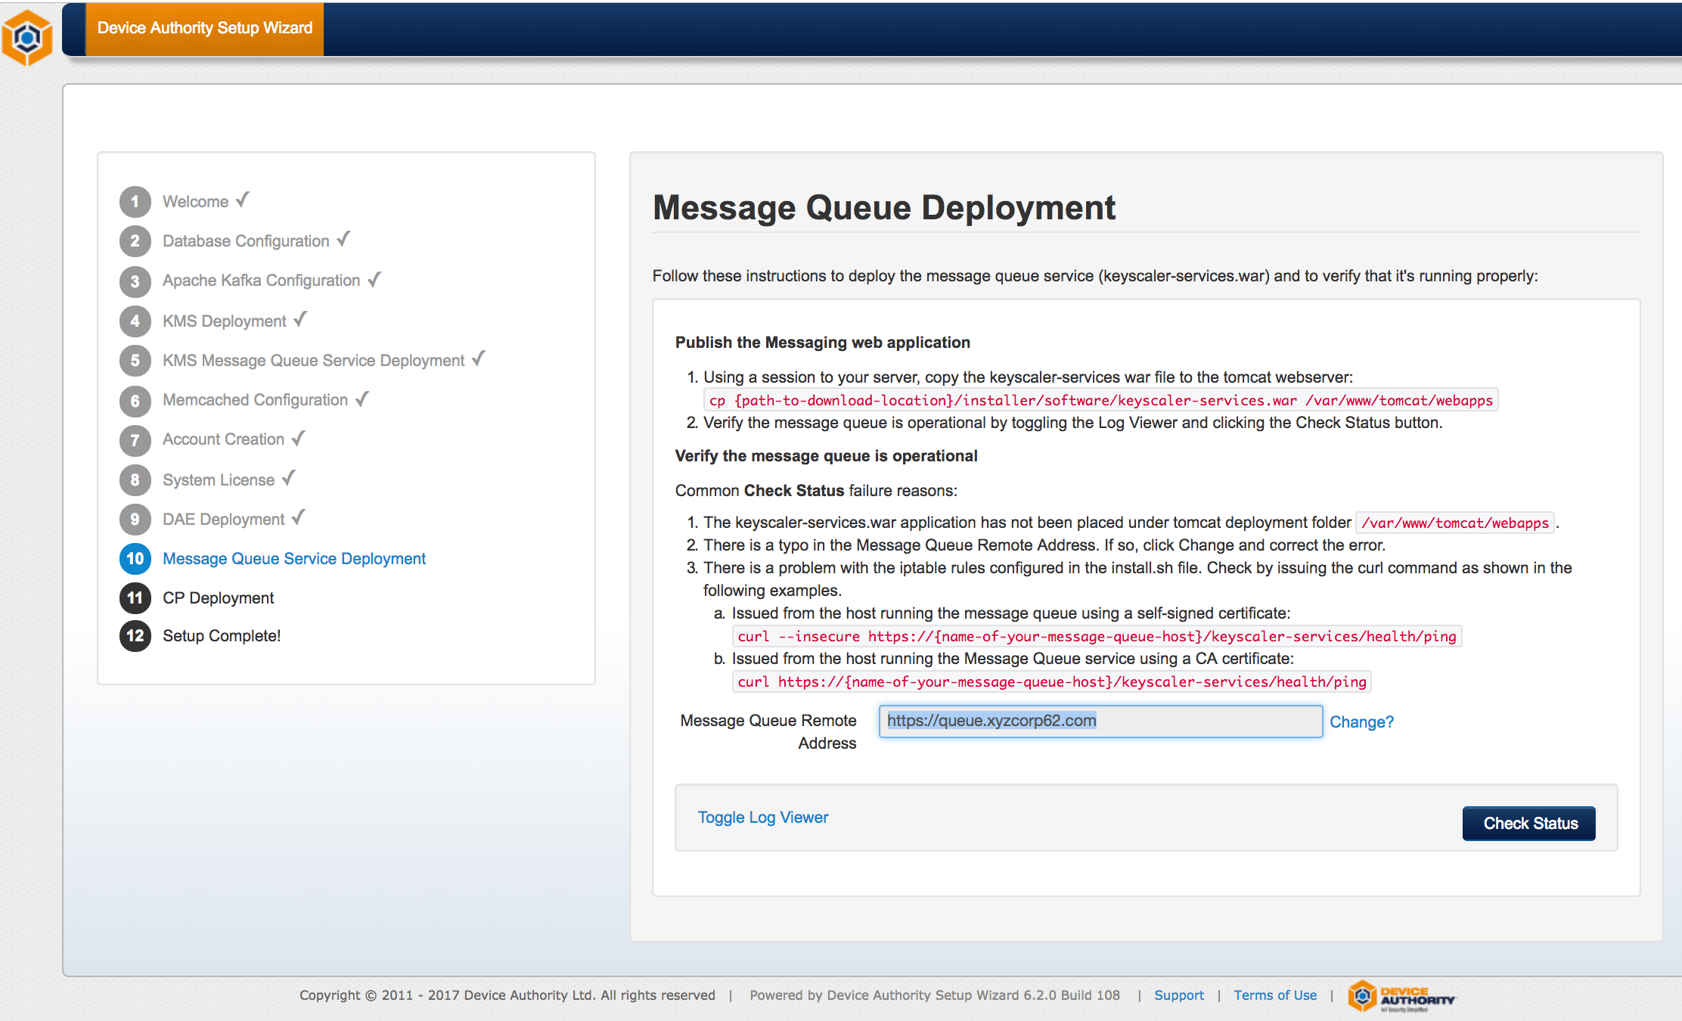
Item 48 - KeyScaler Installation Wizard

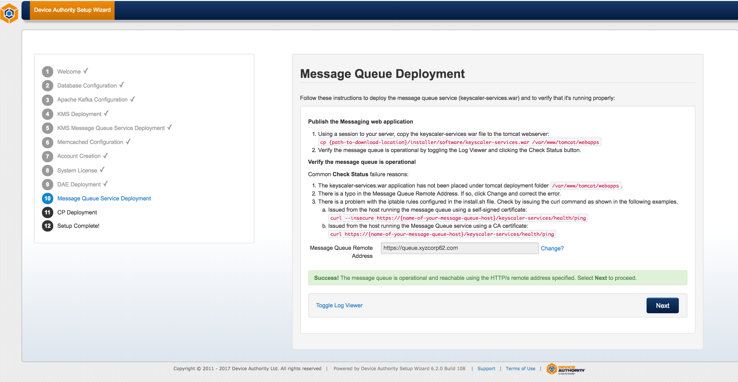
Item 49 - KeyScaler Installation Wizard

CP Deployment

CP Configuration
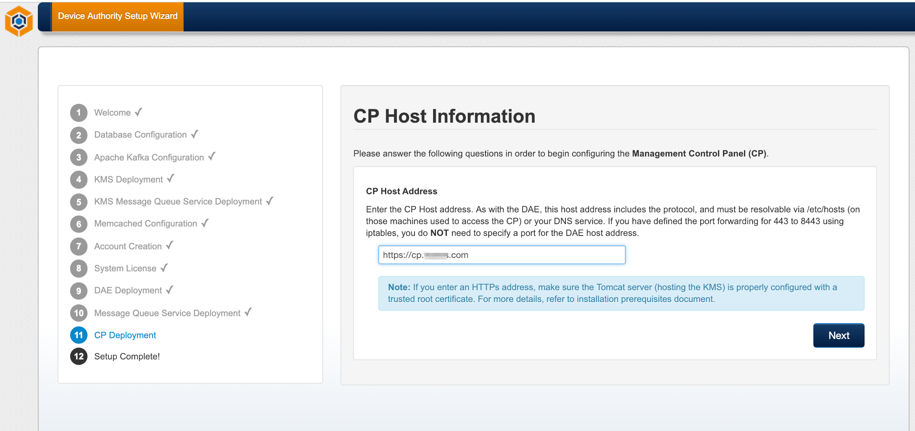

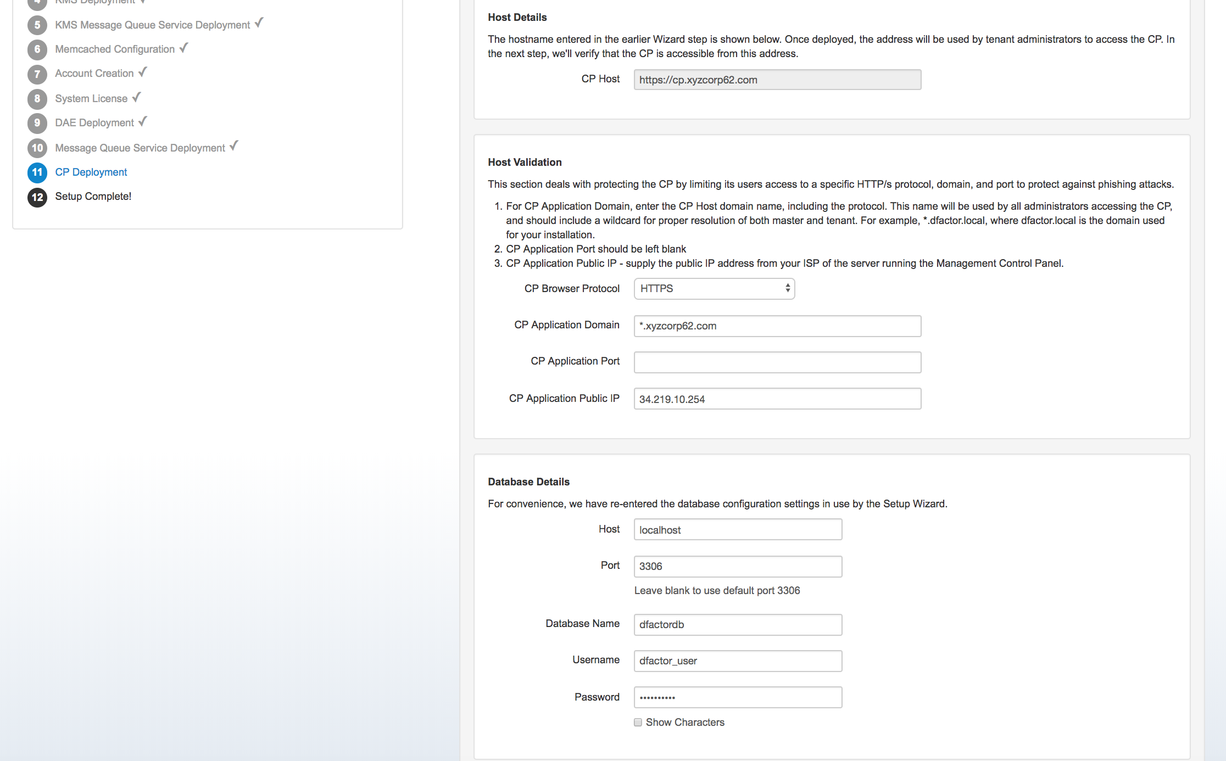
Item 50 - KeyScaler Installation Wizard

CP Deployment

Publish the CP web application
Publish the cp.war by following the instructions in the Wizard. You'll be copying the file to your web application directory

[root@ip-172-31-42-166 software]# cd /home/centos/installer/software
[root@ip-172-31-42-166 software]# cp cp.war /var/www/tomcat/webapps
Item 51

Once published, use the Wizard to verify the cp.war file has deployed properly by clicking Toggle Log Viewer and then Check Status.

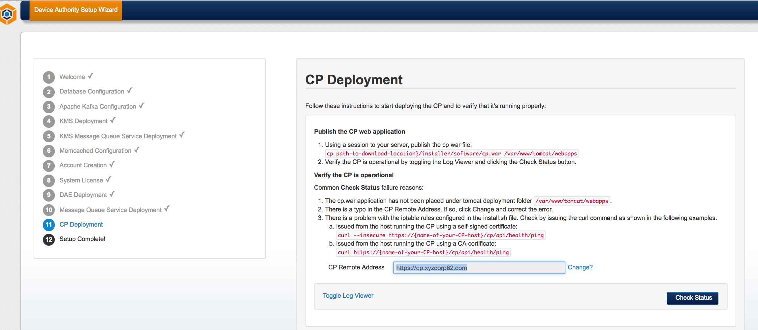
Item 52 - KeyScaler Installation Wizard

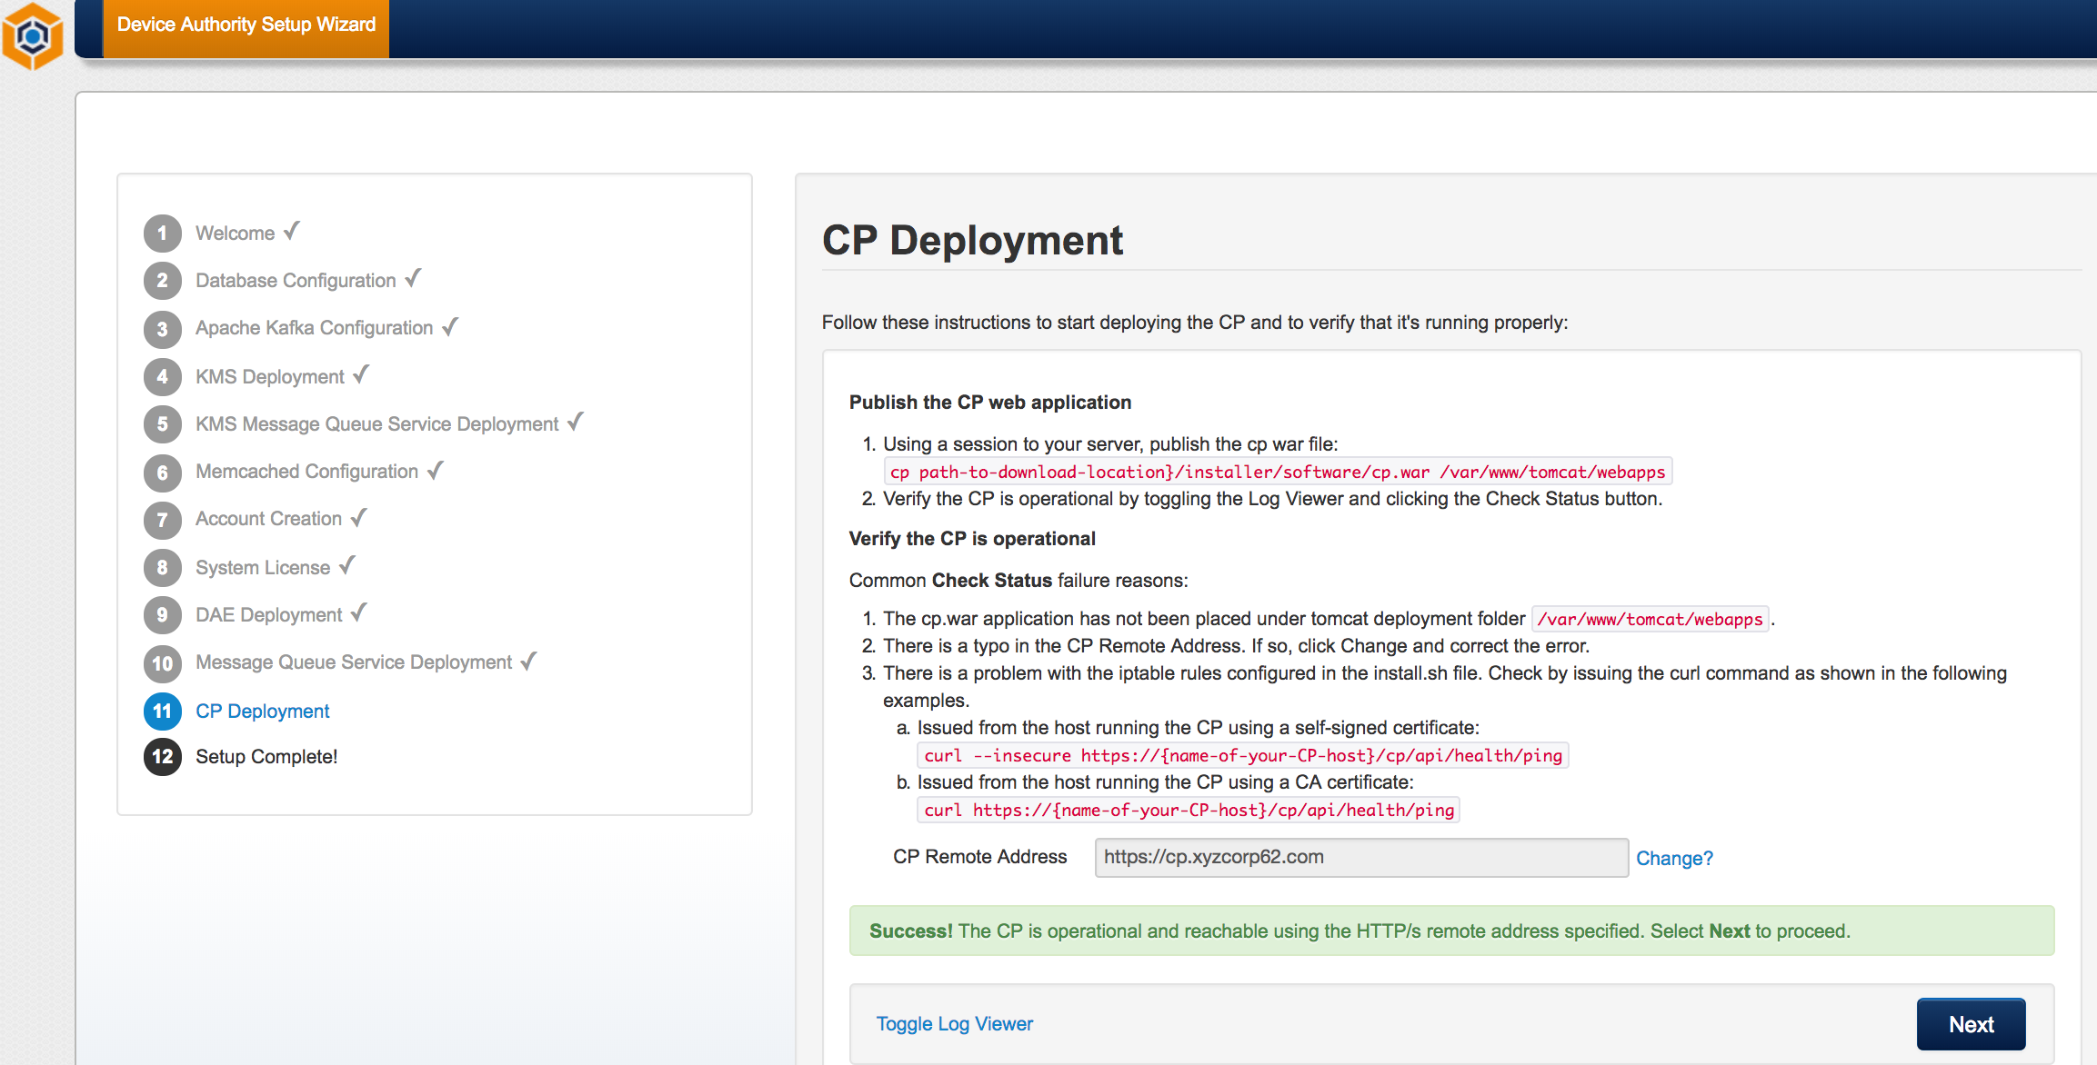
Item 53 - KeyScaler Installation Wizard

Setup Complete
Make sure you note down the Master Account and Tenant Account Numbers or leave the wizard page open as you will need this info in subsequent sections.

Next, please proceed with section 4.2.12.1 to configure license.

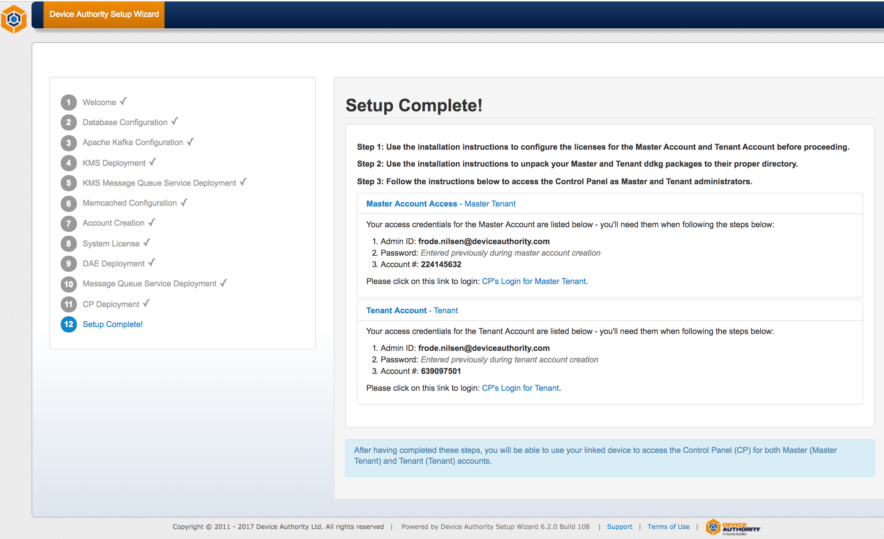
Item 54 – KeyScaler Installation Wizard

Next, you will:

- Configure your licenses for your on-premise Master and Tenant accounts,
- Unpack the Master and Tenant DDKG files, and then
- Use the links in the Wizard to register your first device for CP access.

Configure Licenses
Licenses must be configured for the Master and Tenant Accounts that were created during installation. Licenses are configured using a menu-driven command-line license management tool (na-tool.sh) that is bundled with the DAE. Use the following steps to configure your licenses. Note: The steps outlined in this document must be executed on the server where DAE (service.war) was deployed and must be run as the dfactor_user user.

Below shows an example where there are 15 licenses available, where 5 are allocated for master account and the remaining 10 are allocated for tenant account. Your system will most likely have more than 15 licenses available for use, in which case the numbers you enter below is likely to differ from this example.

[root@ip-172-31-2-31 ec2-user]# su - dfactor_user
Last login: Mon Apr 23 10:13:30 UTC 2018 on pts/1
[dfactor_user@ip-172-31-2-31 ~]$

[dfactor_user@ip-172-31-42-166 conf]$ sh /var/www/tomcat/webapps/service/WEB-INF/classes/tools/bin/na-tool.sh
Using MySQL Connector: /var/www/tomcat/lib/mysql-connector-java-5.1.40-bin.jar
DAE Custom Config File: /var/dfactor/conf/dae.properties exist? true
Running in DAE mode!
DAE Tool/
=========
0. Exit
1. Manage - DAE Master Account
2. Manage - DAE Tenant Account
3. Manage - DAE Account Licenses
4. Manage - DAE System License
5. Troubleshooting
6. DAE Update 5.6
7. DAE Update 5.8
Enter choice: [0 - 7]
3
DAE Tool/Manage - DAE Account Licenses/
=======================================
0. Exit
1. Configure - Master Account License
2. Configure - Tenant Account License
3. Display - Master Account License
4. Display - Tenant Account License
Enter choice: [0 - 4]
1
Enter number of registration seats for Master Account [Available 15]:
5

Will attempt to create license with following information:
Account Number : 204920231
Licensed Product : DAE
Licensed Crypto Module : Yes
Licensed Credential Module : Yes
License Type : TRIAL
License Seat Type : TENANT_DEVICES
License Seat Limits : 5
Transaction Verification : Yes
Expiration (in days) : 1826
Grace Period (in days) : 0

Please review the above information. If the information is correct then confirm to proceed [y/N]:
y
New license has been created for account no 204920231

Hit Enter

DAE Tool/Manage - DAE Account Licenses/
=======================================
0. Exit
1. Configure - Master Account License
2. Configure - Tenant Account License
3. Display - Master Account License
4. Display - Tenant Account License
Enter choice: [0 - 4]
2
Enter Tenant Account Number:
429583582
Enter number of registration seats for Tenant Account [Available 10]:
10

Will attempt to create license with following information:
Account Number : 429583582
Licensed Product : DAE
Licensed Crypto Module : Yes
Licensed Credential Module : Yes
License Type : TRIAL
License Seat Type : TENANT_DEVICES
License Seat Limits : 10
Transaction Verification : Yes
Expiration (in days) : 1826
Grace Period (in days) : 0

Please review the above information. If the information is correct then confirm to proceed [y/N]:
y
New license has been created for account no 429583582

Hit Enter

DAE Tool/Manage - DAE Account Licenses/
=======================================
0. Exit
1. Configure - Master Account License
2. Configure - Tenant Account License
3. Display - Master Account License
4. Display - Tenant Account License
Enter choice: [0 - 4]
0
DAE Tool/
=========
0. Exit
1. Manage - DAE Master Account
2. Manage - DAE Tenant Account
3. Manage - DAE Account Licenses
4. Manage - DAE System License
5. Troubleshooting
6. DAE Update 5.6
7. DAE Update 5.8
Enter choice: [0 - 7]
0
[dfactor_user@ip-172-31-42-166 conf]$
Item 55

Unpack Your DDKGs

Download DDKGs
If you haven't already, Access the Device Authority Customer Portal and download the Client-Side Software Master DDKGs and Tenant DDKGs.

- Master DDKG Downloads - this package contains the DDKGs associated with your Master CP application
- Tenant Account DDKG Downloads - This package contains the DDKGs associated with your Tenant account
- Download the Samples package

Place the DDKGs onto your Management Control Panel home directory
Ensure you have unzip installed
[root@ip]# yum install unzip -y
Item 56
On the server running the Management Control Panel (CP), create a new directory as shown:
[root@ ~]# mkdir /var/dfactor/data/cp-hosted-downloads
Item 57
Unzip the following files into the hosted downloads directory. Assumes you have files in /home/centos directory.
[root@ ~]# unzip /home/centos/master-6.3.zip -d /var/dfactor/data/cp-hosted-downloads
[root@ ~]# unzip /home/centos/tenant-6.3.zip -d /var/dfactor/data/cp-hosted-downloads
[root@ ~]# cd /var/dfactor/data/cp-hosted-downloads/816342084
[root@ ~ 816342084]# unzip core-6.3.zip
[root@ ~ 816342084]# mv core/ddkg .
Item 58
Copy (without unzipping) the samples.zip into the CP's hosted downloads directory:
[root@ ~ 816342084]# cp /home/centos/samples.zip /var/dfactor/data/cp-hosted-downloads

Item 59

Your CP's hosted downloads directory configuration should end up looking similar to Item 60
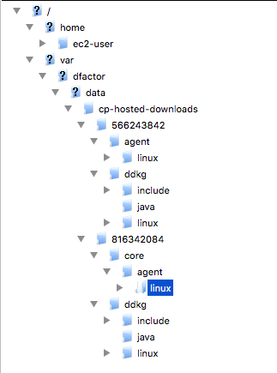
Item 60 – Core Packages

Rename the DDKG directories using your account numbers (find them in Item 54) that are displayed on the Wizard page

[root@ ~]# mv /var/dfactor/data/cp-hosted-downloads/566243842 /var/dfactor/data/cp-hosted-downloads/<your_MASTER_account_number>
[root@ ~]# mv /var/dfactor/data/cp-hosted-downloads/816342084 /var/dfactor/data/cp-hosted-downloads/<your_TENANT_account_number>
Item 61
Change ownership of the new directory and all files to dfactor_user

[root@ ~]# chown -R dfactor_user:tomcat /var/dfactor/data/cp-hosted-downloads
Item 62

CP Access
Note: Master and tenant host name must be resolvable by your DNS. The preferred method is to create DNS entries for each, however, you can also provide access by creating /etc/host entries on the desktop or laptop you'll use to access the CP.

Please note: You will need to replace the below domain name (xyzcorp) to match your own domain name.

# localhost name resolution is handled within DNS itself.
# 127.0.0.1 localhost
# ::1 localhost

54.186.32.181 master.ksaws.com
54.186.32.181 tenant.ksaws.com
Item 63 – Example of /etc/hosts file on your local computer that you will use to access the KeyScaler Control Panel.

Now you should be able to access the tenant by typing a URL similar to the following into your browser as shown below https://tenant.ksaws.com/cp/, alternatively clicking on the following links on the Setup Complete wizard page.
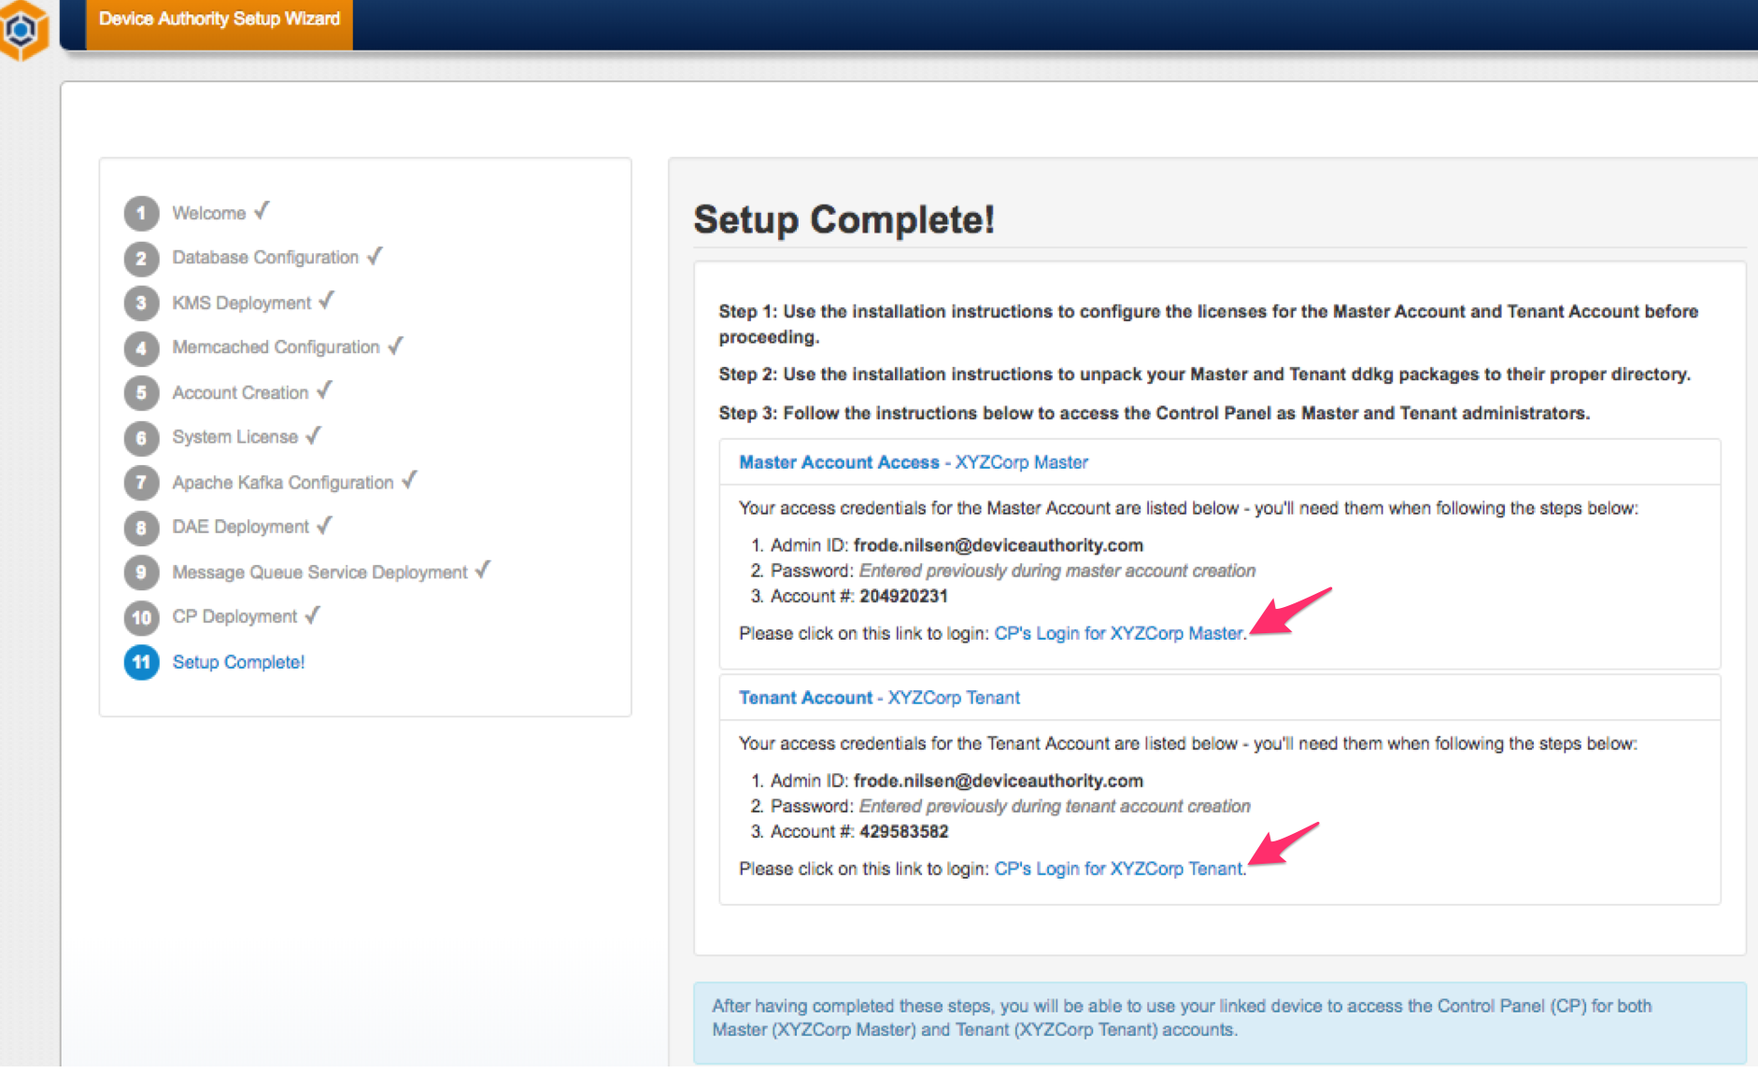
Item 64 - KeyScaler Installation Wizard - The Setup Complete Wizard page contains links to the Master and Tenant Accounts pointed to by the above two arrows.

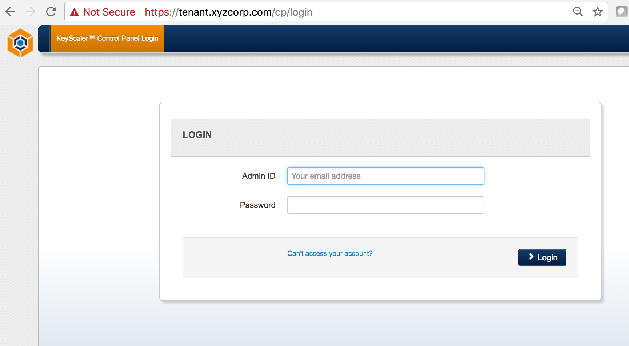
Item 65 - https://master.ksaws.com/cp/ and https://tenant.ksaws.com/cp/ Note: If you installed using a self-signed certificate you will see the red ‘Not Secure’ warning message, as this will not be trusted by the browser. You should use a CA trusted certificate for a production installation. To access the master tenant use URL https://master.ksaws.com/cp/.

Once logged in you will see a page similar to the following.
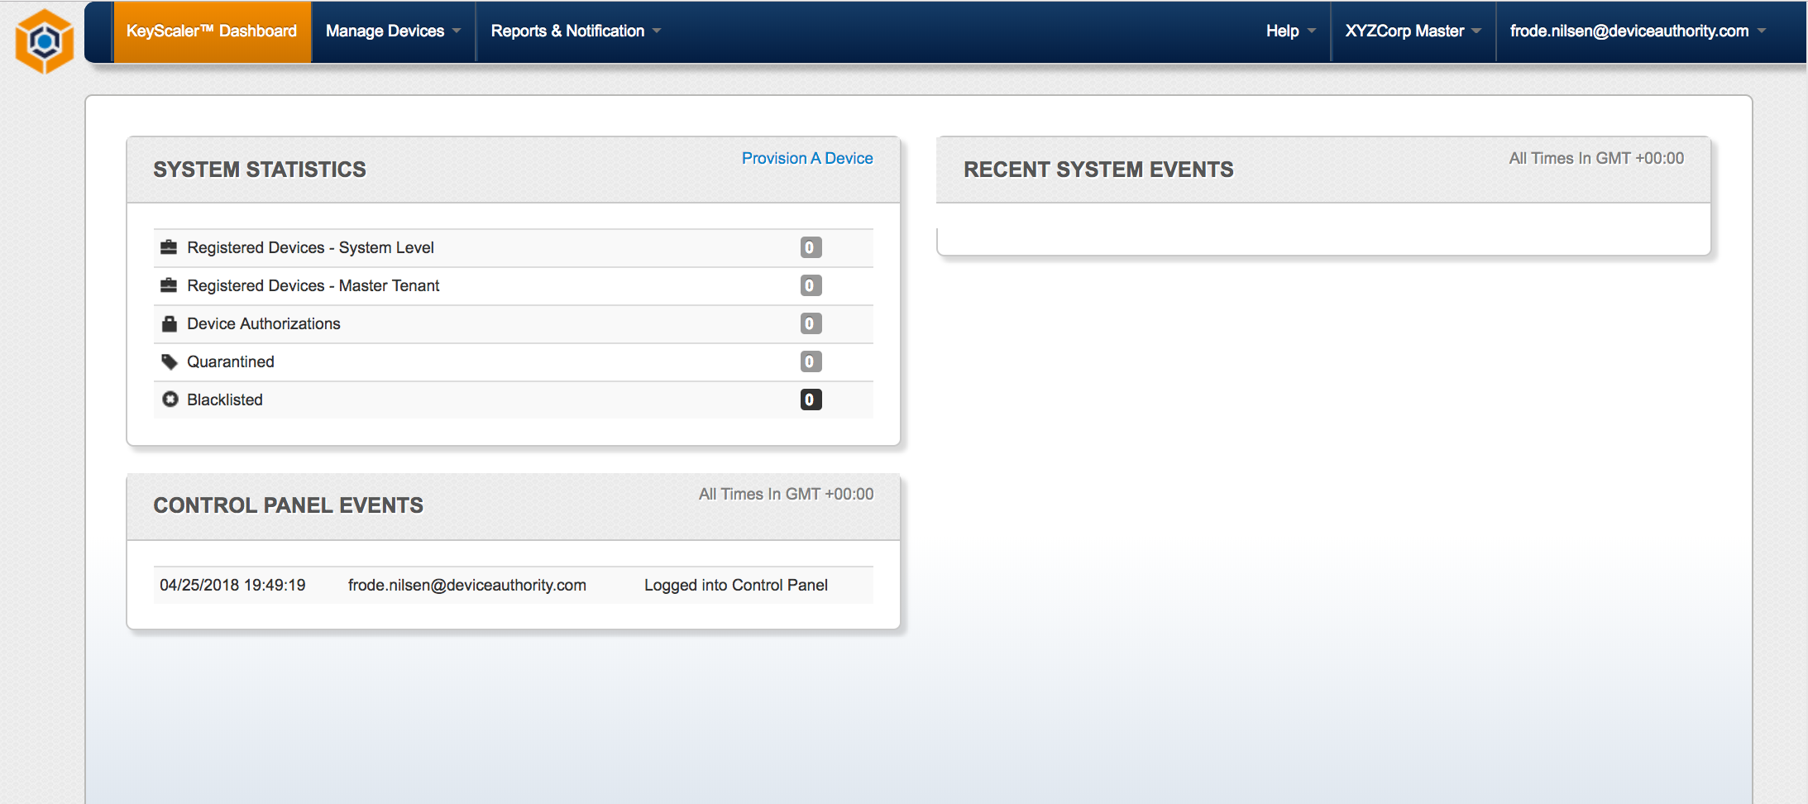
Item 66 – KeyScaler Control Panel

Next, there are some post-installation activities in section 4.4, which are necessary if you want to fully configure your system to handle notifications and configure outgoing emails etc. This can also be done later, in which case you can jump to the installation of the Service Access Controller in section 5.

Next, before continuing with section 4.5 Post-Installation Activities, you can continue with section 5 Service Access Controller Installation

Helpful Information
By default, CP access is allowed without device authentication. Instructions on enforcing CP access by device authentication are provided in the Control Panel User Guide.

Different DDKG plugins are used to access the Device Authority CP, your on-prem CP as a Master administrator and your on-prem CP as Tenant administrator. When each plugin is first used by the browser, you must allow the DDKG plugin to run in order to gain access to the CP. For Chrome users, you also need to install the Chrome DDKG Extension. The link will be provided on screen and is also available here.

Post-Installation Activities
Following the completion of the installation, there are some activities needed to configure your installation. These can be found here in the next sections.

Account Settings

General Settings
Change the time zone used to display alerts and data in the CP if desired.

Email URIs for PC Devices
On the Account Settings tab, supply the following URIs so administrators will receive well-formed links in the Administrator invite email to send when creating new administrators. The domain portion of the URI will have to be modified to match your environment. In the examples below, the domain for master CP access is master.ksaws.com This domain was specified during the installation Wizard.

Login URI: https://master.xycorp62.com/cp/login

Registration URI: https://master.ksaws.com/cp/registerdevice

Download URI: https://master.ksaws.coml/cp/downloadddkg

Manage Notifications
(Optional) Customize the email templates used when sending out email notifications to CP administrators. In addition, you can control who will receive notifications on this page

Configure Outgoing Mail
The Management Control Panel (CP) sends out emails for various notification purposes (invitations for new administrator access, alerts, etc.), and you'll need to set up the SMTP credentials for successful email delivery for both CP alerts and application alerts. To configure email, select Configure Outgoing Mail, and supply the requested parameters. Values appropriate for your installation can usually be obtained from your IT Operations department.

The following parameters are needed:

- Protocol
- Mail Server Host
- Server Port Number
- From Address
- TLS
- User Name
- Password

Manage Administrators
It is a good practice to have at least two administrators authorized to access the CP as Master Admin. Use the Manage Administrators tab to create a new Master CP admin. This feature can also be used to create administrators for your tenant(s) accounts, by selecting the appropriate Organization Name. This step should be done after SMTP has been set up and tested so the new administrators receive an email invitation with their credentials.

Tenant Account Setup
Following the installation of your DAE and CP, there are a few housekeeping steps to complete your installation. These functions are all found by accessing your CP tenant and going to the pull-down menu under the tenant name on the CP header.

Account Settings
URI Setup - for PC Devices
(Optional, and only needed if you are using device authentication for end-user application access.)

URI Setup - for PC Devices
(Optional, and only needed if you are using device authentication for end-user application access.)

On the Account Settings tab, supply the following URIs if email notifications are to be sent out from your application. These settings are needed so end-users will receive well-formed links in the invitations to register their devices. The domain portion of the URI will have to be modified to match your environment. In the examples below, the domain for tenant CP access is https://mytenant.ksaws.com . This domain was specified during the installation Wizard.

Login URI: https://mytenant.ksaws.com/cp/login

Registration URI: https://mytenant.ksaws.com/cp/registerdevic

Download URI: https://mytenant.ksaws.com/cp/downloadddkg

Manage Notifications
When logged into the CP as a tenant admin, the notification templates are used when sending notifications generated by application (end-user or IoT device) access. These can be customized if desired.

In addition, you can control who will receive notifications on this page.

Manage Administrators
It is a good practice to have at least two administrators authorized to access the CP as Tenant Admins. Use the Manage Administrators tab to create a new Tenant CP admin. This step should be done after SMTP has been set up and tested so the new administrators receive an email invitation with their credentials.

Manage DAE API Settings
To increase the security of your system, you can limit the Extended API calls that will be accepted by your DAE by disabling those API calls not used. While developing your system, it is often useful to enable all extended APIs in your system, and then selectively disable unused APIs prior to deploying your production application.

Other Configuration Customization's

Blocking the Wizard from General Access
Once your system is installed, it is desirable to redirect anyone browsing to your KeyScaler server and make sure the Management Control Panel is loaded instead of the Installation Wizard. To do this, edit the file /var/www/tomcat/webapps/ROOT/index.html to contain only the following line:

<meta http-equiv="refresh" content="0;url=/cp/"/>

Installing DFACTOR Tools
We provide a download package called DFACTOR tools which is available from the Software Section of the Customer Portal. This is a collection of useful scripts and programs. Use the instructions Deploying the D-FACTOR Tools to install the DFACTOR tools.

Master Account Setup
These functions are all found by accessing your master tenant and going to the pull-down menu under the tenant name on the CP header.

DAE And CP Configuration
Following the installation of your DAE and CP, there are a few housekeeping steps to complete your installation. These steps are separated by tasks to be performed as Master Account administrator and those to be performed as Tenant Account administrator.

Orientation to your KeyScaler System
This section describes key files, directories, users and commands useful for administering your KeyScaler system.

Database
KeyScaler uses a MySQL database. When the DAE or CP accesses the database, both programs use the database user dfactor_user. In the DAE, KMS and CP Installation Prerequisites, it was recommended that you change the database passwords. Should you need to change these database passwords in the future, please contact customer_support for instructions on how to change database passwords as they are stored in encrypted form in KeyScaler configuration files.

Default Database Name | Database Users
dfactordb | root, dfactor_use
Item 67

Linux User

The Linux user dfactor_user owns the KeyScaler web applications (DAE, KMS and CP). It is occasionally necessary to run certain KeyScaler programs and tools as the dfactor_user. To do so, use the Linux "su" command as illustrated. Please use the - option to properly set environment variables for the dfactor_user.

su - dfactor_user
Item 68

Log files
The CP, DAE, KMS and Wizard create log files for normal operational and error messages. Depending on system activity, the DAE and CP log files can grow in size and may need to be periodically removed or archived to another server.

Program | Logfile Location and Name | Rotated Logfile Location
CP | /var/dfactor/logs/cp.log | /var/dfactor/logs/older/<yyyy-mm>
DAE | /var/dfactor/logs/dae.log | /var/dfactor/logs/<yyyy-mm>
KMS | /var/dfactor/logs/kms.log | no rotation needed
NA-Tools | /var/dfactor/logs/na-tools.log | no rotation needed
Install Wizard | /var/dfactor/logs/wizard.log | no rotation needed
Item 69

To unzip log files that have been rotated and compressed use the gunzip utility. For example: gunzip <filename>

Tomcat
The Tomcat Web application creates its own logs in /var/www/tomcat/logs. The information contained in these logs are generally specific to Tomcat, and not the KeyScaler platform. These log files should be monitored periodically and archived if needed.

Tomcat Location | Tomcat Logfile Location
/var/www/tomcat/webapps | /var/www/tomcat/logs/catalina.out, and others
Item 70

Helpful Commands

Start KeyScaler
[root]# service dfactor start
Item 71 – starting the tomcat service

Stop KeyScaler
[root]# service dfactor stop
Item 72 – stopping the tomcat service

Check If KeyScaler is running
[root]# service dfactor status
Item 73 – check status of tomcat service

Run NA Tool - used to configure your KeyScaler license
[root]# su - dfactor_user
[dfactor_user]# sh /var/www/tomcat/webapps/service/WEB-INF/classes/tools/bin/na-tool.sh
Item 74

Check to see if KeyScaler is running via Browser
From a browser, issue the following commands from the URL bar. Response will vary but should be similar to what is shown.

https://<url_of_your_keyscaler_server>/service/api/health/ping
{"req_id":"cbf6ffea-dbdd-4c82-a96b-7179a8ac1e21","response_ts":1498847206761,"http_code":200,"status_code":0,"response_data":null}

https://<url_of_your_keyscaler_server>/kms/api/health/ping
{"req_id":"f89dfd67-c444-4dbf-ad84-4fa27bbd3484","response_ts":1498846769391,"http_code":200,"status_code":10000}
Item 75

Troubleshooting

Oh Snap! Maximum status check attempts exceeded
Oh Snap! Maximum status check attempts exceeded. Response received: Connection refused (Connection refused). Verify that the HTTP/s remote address entered above is correct and accessible via internal networks, and try again...
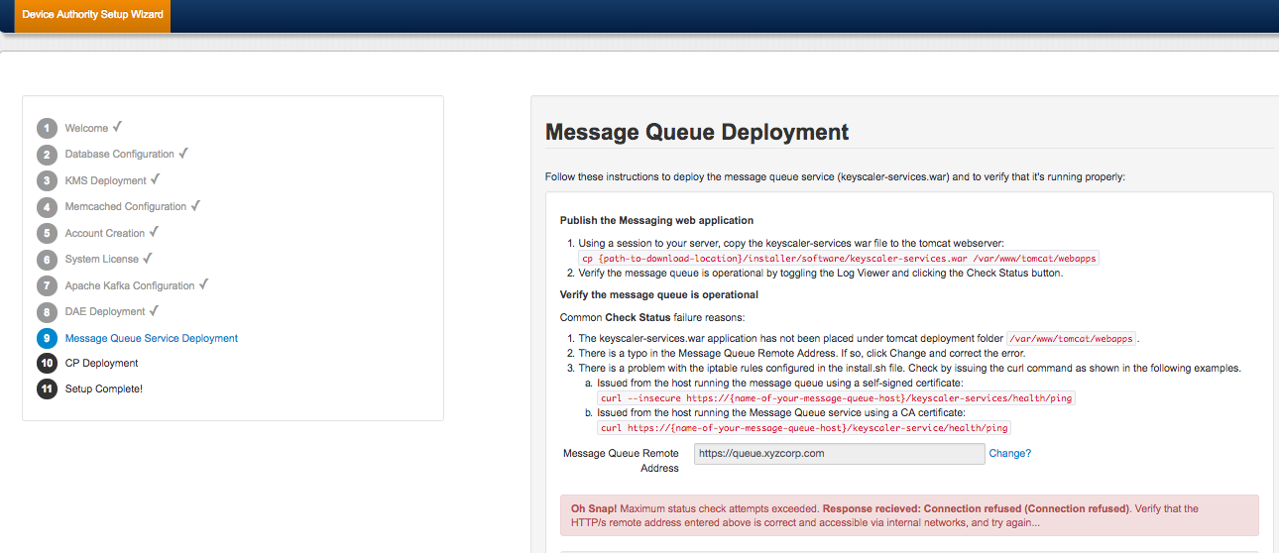
Item 76

Fix – Update hosts file
Ensure the bold entry is present in the hosts file.

[root@ip-172-31-42-166 software]# cat /etc/hosts
127.0.0.1 localhost localhost.localdomain localhost4 localhost4.localdomain4
::1 localhost localhost.localdomain localhost6 localhost6.localdomain6

127.0.0.1 kms.ksaws.com
127.0.0.1 kafka.ksaws.com
127.0.0.1 dae.ksaws.com
127.0.0.1 queue.ksaws.com
[root@ip-172-31-42-166 software]#
Item 77

Service Access Controller Installation

Overview
The Device Authority Service Access Controller (SAC) is a web application that provides an out-of-the-box management service for managed Device Authority Gateway Agents. It has been designed to keep external TCP/IP traffic from ever connecting directly to internal infrastructure, such as the core Device Authority Engine API, or database instances. On a production environment the SAC should be installed on its own server, but it is possible to have the SAC running on the same server as that of the KeyScaler system (See 5.3)

On Standalone Server

Pre-requisites
For a production environment it is recommended that the SAC is installed on a separate server. Please review the following documents to ensure you have met all the necessary hardware and software requirements for the Service Access Controller.
- https://deviceauthority.zendesk.com/hc/en-us/articles/217078538-KeyScaler-Hardware-Requirements
- https://deviceauthority.zendesk.com/hc/en-us/articles/217078568

Create a single dedicated Linux server instance and install and/or complete the following prerequisites.

Java Runtime Environment (JRE) 1.8
From oracle pages, download Java 8 as follows:

http://www.oracle.com/technetwork/java/javase/downloads/jdk8-downloads-2133151.html

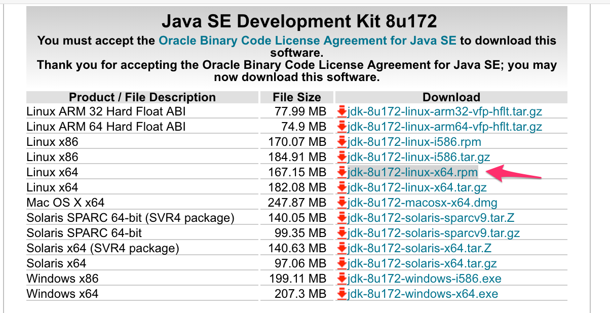
Item 78 – Java Download

Right click on link in Item 78 and Copy Link Address to clipboard.
http://download.oracle.com/otn-pub/java/jdk/8u191-b12/2787e4a523244c269598db4e85c51e0c/jdk-8u191-linux-x64.rpm
[ec2-user@ip-172-31-40-78 ~]$ sudo yum install wget -y
Item 79 – Service Access Controller
Download Java using the URL copied above.
[ec2-user@ip-172-31-40-78 ~]$ sudo wget --header "Cookie: oraclelicense=accept-securebackup-cookie" http://download.oracle.com/otn-pub/java/jdk/8u191-b12/2787e4a523244c269598db4e85c51e0c/jdk-8u191-linux-x64.rpm
Item 80
Install Java
[ec2-user@ip-172-31-40-78 ~]$ sudo yum localinstall jdk-8u191-linux-x64.rpm
Item 81

[ec2-user@ip-172-31-26-184 ~]$ java -version
java version "1.8.0_191"
Java(TM) SE Runtime Environment (build 1.8.0_191-b12)
Java HotSpot(TM) 64-Bit Server VM (build 25.191-b12, mixed mode)
[ec2-user@ip-172-31-26-184 ~]$
Item 82

Apache Tomcat 7

Go to apache tomcat site and right click tar.gz link and Copy Link Address.

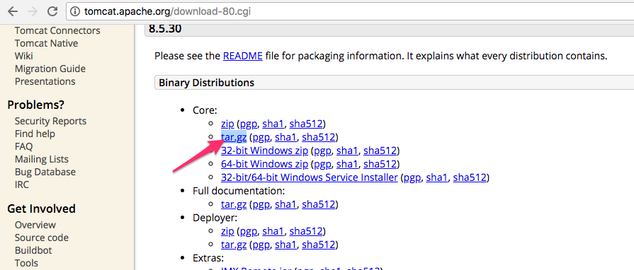
Item 83 – Tomcat downlaod

[ec2-user@ip-172-31-40-78 ~]$ sudo wget http://www.mirrorservice.org/sites/ftp.apache.org/tomcat/tomcat-8/v8.5.34/bin/apache-tomcat-8.5.34.tar.gz
Item 84

[ec2-user@ip-172-31-40-78 ~]$ sudo tar -xvzf apache-tomcat-8.5.34.tar.gz
Item 85

Communicating over HTTPS
Please see 5.5.1.1 in pre-requisites section

Install Instructions
Please use these instructions to install the SAC on a standalone server. These instructions are to be run as root unless otherwise instructed. For AWS instances, you'll need to issue the command sudo su to gain root access before beginning.

Transfer the Service Access Controller Package to Your Server
On your KeyScaler server, locate the installer, e.g. /home/centos/installer/software (see Item 6), locate the sac.tar.gz file and transfer it to your server. This document will assume sac.tar.gz is uploaded to the /home/centos directory

Unpack the sac.tar.gz file
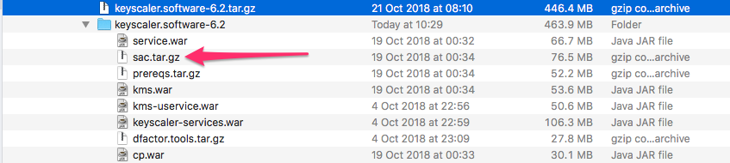
Item 86 - KeyScaler Server – Upload the following file to the SAC Server
$ scp -i <keyfile>.pem /Users/fbnilsen/Documents/ks6.2_2018-10-21/keyscaler.software-6.2/sac.tar.gz ec2-user@<SAC HOST>:/home/centos
Item 87 – Local Computer – Upload the sac.tar.gz file to the SAC server

Unpacking this file will result in service-access-controller.war, which will be deployed shortly.

[root@ip-172-31-40-78 ec2-user]# cd /home/centos
[root@ip-172-31-40-78 ec2-user]# tar -xvzf sac.tar.gz
service-access-controller.war
Item 88

Create Service User
The Service Access Controller runs as an application within the Tomcat web service. To keep configuration consistent, create a service user for running Tomcat.

[root@ip-172-31-40-78 ec2-user]# groupadd tomcat
Item 89 – Tomcat group

Then create the new service user as a member of that new group:
[root@ip-172-31-40-78 ec2-user]# useradd -s /bin/bash -g tomcat dfactor_user
Item 90 – add user to tomcat group

Create Necessary Directories
There are a few directories that will need to be present to complete the service setup. Note the /var/dfactor directory may exists if a self-signed certificate was created in DAKS-62-INST-KEYSCALER_PREREQUISITES.docx.

[root@ip-172-31-40-78 ec2-user]# mkdir /var/www
[root@ip-172-31-40-78 ec2-user]# mkdir /var/dfactor
[root@ip-172-31-40-78 ec2-user]# mkdir /var/dfactor/conf
[root@ip-172-31-40-78 ec2-user]# mkdir /var/dfactor/logs
Item 91 – Create directories

Copy Tomcat to /var/lib
[root@ip-172-31-40-78 ec2-user]# cp -r apache-tomcat-8.5.34 /var/lib/apache-tomcat-8.5.34
Item 92

Symbolic link
Create a symbolic link in the newly created '/var/www' directory to the Tomcat folder

[root@ip-172-31-40-78 ec2-user]# ln -s /var/lib/apache-tomcat-8.5.34/ /var/www/tomcat
Item 93

Configure Tomcat and Service Access Controller
Create the configuration file that will be read by the Service Access Controller on service Startup. Note this file does not exist yet, so create it as shown next.

[root@ip-172-31-40-78 ec2-user]# vi /var/dfactor/conf/sac.properties
Item 94 – create sac.properties file
Copy/Paste the following example (Item 95 – sac.properties) config into the file and fill out the details appropriate to your environment. For a basic provisioning system, the only properties that you would have to change to get up and running with a basic provisioning system are the bold properties. Use Error! Reference source not found. as a guideline for each parameter:

deviceAuthenticationService=https://dae.ksaws.com
multiTenancy=false
participantId=4132c7d2-6f21-4c74-ad93-8d5c4a7fcabe
participantSecret=65a24097-c97d-42b7-a45c-d09f092e5926
hostVerificationProtocol=https
hostVerificationDomain=sac.ksaws.com
hostVerificationWildcardDomain =
hostVerificationDomainPublicIP=18.236.164.27
hostVerificationPort =
schedule.orders.new=800000000
schedule.orders.pending=800000000
schedule.orders.revoked=800000000
schedule.orders.renewal=1240000000
schedule.awsiot.new=8640000000
schedule.awsiot.status=8640000000
schedule.mpowners.new=8640000000

Item 95 – sac.properties (relates to step: Item 110
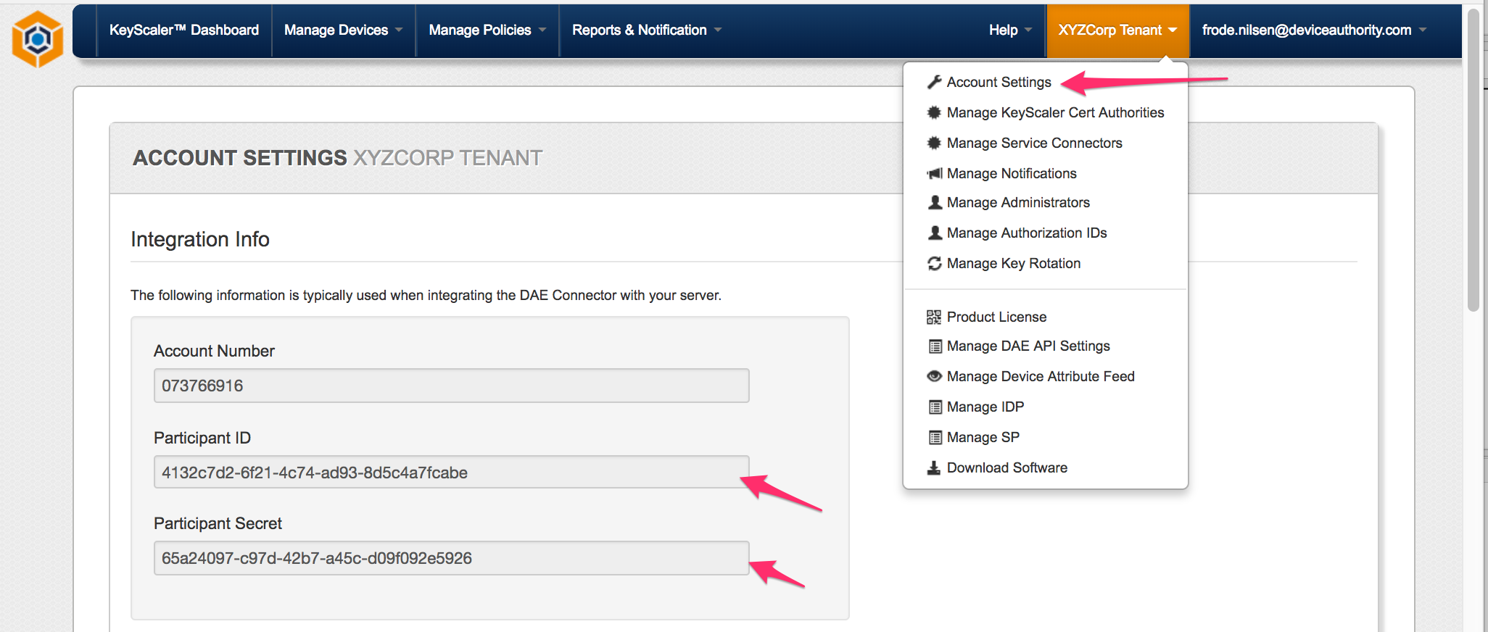
Item 96 – participantId and participantSecret

Install service-access-controller.war into Tomcat
The Service Access Controller application is deployed much like any other Tomcat web application. You can simply copy the .war file into the $TOMCAT_HOME/webapps directory, and it will auto-extract on service start.

[root@ip-172-31-40-78 ec2-user]# cd /home/centos
[root@ip-172-31-40-78 ec2-user]# cp service-access-controller.war /var/www/tomcat/webapps
Item 97

Set permissions
Remove write permissions for the core Tomcat directory
[root@ip-172-31-40-78 ec2-user]# chmod -R go-w /var/www/tomcat
Item 98

Change to the Tomcat directory and give ownership of the appropriate sub-directories to the service user that was created in Item 91
[root@ip-172-31-40-78 ec2-user]# cd /var/www/tomcat
[root@ip-172-31-40-78 tomcat]# chown -R dfactor_user:tomcat webapps/ work/ temp/ logs/ conf/ bin/ lib/
[root@ip-172-31-40-78 tomcat]# chown -R dfactor_user:tomcat /var/dfactor
Item 99

Configure Tomcat SSL Connector
At this stage, you have an SSL Certificate, and need to configure Tomcat to use it when sending/receiving traffic over SSL/HTTPs. Update the server.xml file to specify the name and location of your p12 file along with the keystore password you supplied when creating the p12 file.

Edit the file /var/www/tomcat/conf/server.xml and add the following connector definition

[root@ip-172-31-4-186 cert]# vi /var/www/tomcat/conf/server.xml
Item 100

<Connector port="8443" protocol="org.apache.coyote.http11.Http11NioProtocol"
SSLEnabled="true"
scheme="https"
secure="true"
clientAuth="false"
sslProtocol="TLS"

maxHttpHeaderSize="8192"
maxThreads="150"
minSpareThreads="25"
enableLookups="false"
disableUploadTimeout="true"
acceptCount="100"
useBodyEncodingForURI="true"

keystoreType="pkcs12"
keystoreFile="/var/dfactor/cert/self_sign_certificate.p12"
keystorePass="mypassword" />

Item 101

[root@ip-172-31-40-78 tomcat]# su - dfactor_user
[dfactor_user@ip-172-31-40-78 ~]$ /var/www/tomcat/bin/startup.sh
[dfactor_user@ip-172-31-40-78 ~]$ /var/www/tomcat/bin/shutdown.sh
[dfactor_user@ip-172-31-40-78 ~]$ tail -f /var/www/tomcat/logs/catalina.out
Item 102

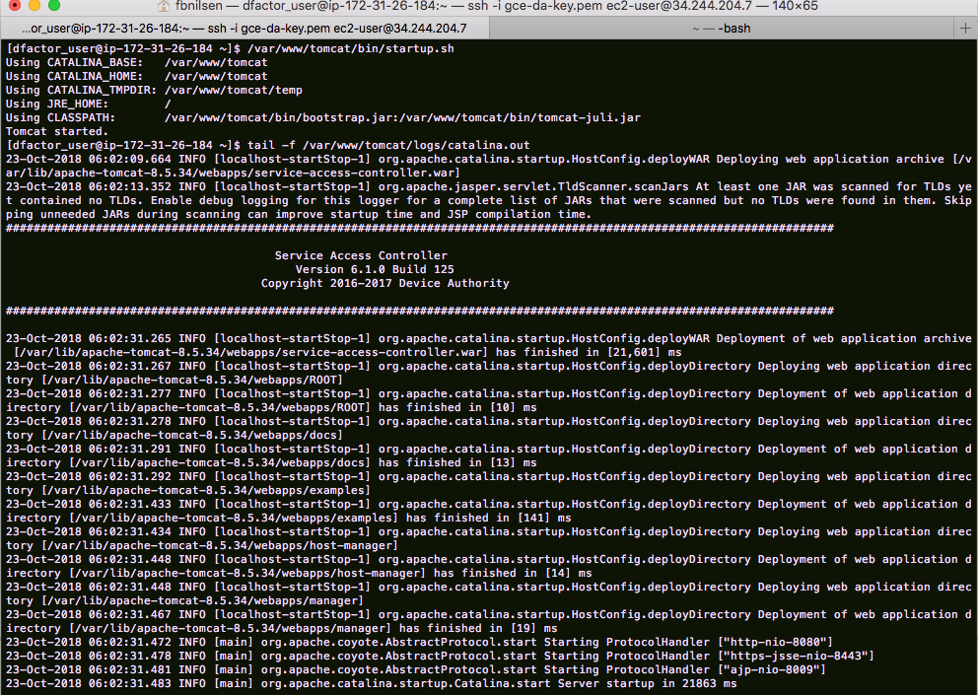
Item 103

DNS Entry
Note: In order for the SAC to communicate to KeyScaler, the following entry 34.212.224.67 dae.ksaws.com must be added to the /etc/hosts entry on the SAC server, where 34.212.224.67 is the IP Address of the KeyScaler system.

[ec2-user@ip-172-31-40-78 ~]$ cat /etc/hosts
127.0.0.1 localhost localhost.localdomain localhost4 localhost4.localdomain4
::1 localhost localhost.localdomain localhost6 localhost6.localdomain6

34.212.224.67 dae.ksaws.com
[ec2-user@ip-172-31-40-78 ~]$
Item 104

Connectivity Tests

Curl from local computer to SAC
Note: The hostname sac.ksaws.com in Item 106 needs to be resolvable by either an /etc/hosts entry on your local computer (Item 105) or a public DNS entry. If resolving by /etc/hosts, your hosts file will have the following entry, where 18.236.164.27 is the IP address of the SAC.

18.236.164.27 sac.ksaws.com
Item 105

frodes-MBP-9:~ fbnilsen$ curl -k https://sac.ksaws.com:8443/service-access-controller/health/ping
{"requestId":"b8f58d85-41cf-471f-9c5c-ab7f846cf59a","responseTimestamp":1524579718653,"httpCode":200,"statusCode":0,"message":null,"assets":[]}frodes-MBP-9:~ fbnilsen$
Item 106

Curl from SAC to KeyScaler
[ec2-user@ip-172-31-40-78 ~]$ curl -k https://dae.ksaws.com:8443/service/api/health/ping
{"req_id":"2d1e638f-4b1e-4260-b85c-019457a24f72","response_ts":1524580057004,"http_code":200,"status_code":0,"response_data":null}[ec2-user@ip-172-31-40-78 ~]$
Item 107

On Same Server
Install the Service Access Controller on the same server on which the KeyScaler system was installed. Please use the instructions below to install the SAC on the same server used to run KeyScaler. On your KeyScaler server, change the directory to the installer directory in Item 108

[root@ ~]# cd /home/centos/installer/software
Item 108

Unpack the sac.tar.gz file
[root@ ~]# tar -xvzf sac.tar.gz
Item 109

Configure Tomcat and Service Access Controller

[root@ip-172-31-22-20 ec2-user]# vi /var/dfactor/conf/sac.properties
Item 110
Please refer to “Item 95 – sac.properties” for example configuration that you can use.

Install service-access-controller.war into Tomcat
The Service Access Controller application is deployed much like any other Tomcat web application. You can simply copy the .war file into the $TOMCAT_HOME/webapps directory, and it will auto-extract on service start.

Copy the 'service-access-controller.war' file to the 'webapps' directory in the Tomcat installation folder
cp service-access-controller.war /var/www/tomcat/webapps/
Item 111

Start the KeyScaler DFactor Service
Since you are deploying the SAC on same server as KeyScaler, it is likely the Tomcat service is already running.
[root@ip-172-31-22-20 ~]$ service dfactor restart
Item 112 - If the service is not running, start the service
[root@ip-172-31-22-20 ~]$ tail -f /var/www/tomcat/logs/catalina.out
Item 113 - Tail the catalina.out log file to make sure the service has started successfully. You should see output similar to the following:

[root@ip-172-31-22-20 ~]$ tail -f /var/www/tomcat/logs/catalina.out
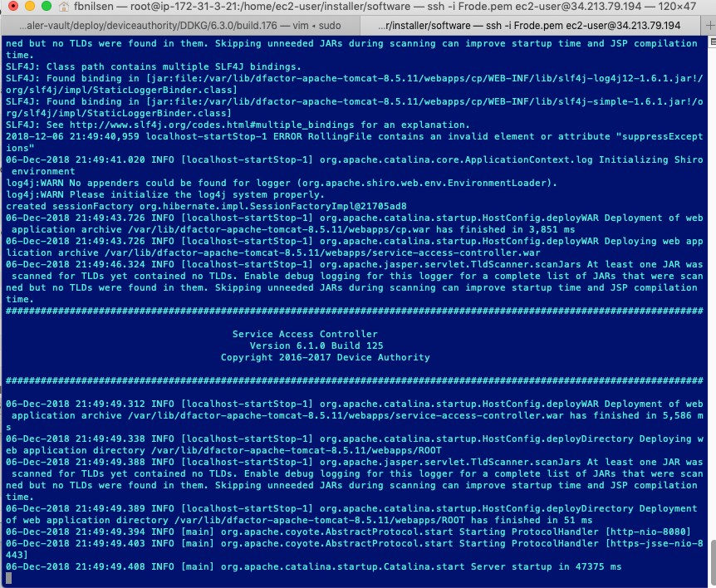
Item 114 - Tail the catalina.out log file to make sure the service has started successfully. You should see output similar to the above
[dfactor_user@ip-172-31-22-20 ~]$ tail -f /var/dfactor/logs/sac.log
Item 115 - Tail the sac.log file in /var/dfactor/logs, checking for errors. Once the SAC has been launched, error and diagnostic information will be entered in the sac.log file.
Note: The hostname sac.ksaws.com resolvable by either an /etc/hosts entry on your local computer or a public DNS entry. If resolving by /etc/hosts, your hosts file will have the following entry, where 35.166.122.161 is the IP address of the SAC.

127.0.0.1 sac.ksaws.com
Item 116 - /etc/hosts
Test connectivity from your laptop to the SAC by running following curl command from your laptop.

frodes-MBP-9:~ fbnilsen$ curl -k https://sac.ksaws.com:8443/service-access-controller/health/ping
{"requestId":"72be70bc-2d1b-4b43-b77d-aed938816e80","responseTimestamp":1524687633452,"httpCode":200,"statusCode":0,"message":null,"assets":[]}frodes-MBP-9:~ fbnilsen$
Item 117 – curl command connectivity test

End to End Sanity Test
End to end sanity test can be performed by installing and registering the MQTT Agent with the KeyScaler System, please see [3] for details on how to set this up.

